Framework for Correlating Security Anomalies with Classification of PII to Identify Data Theft Attacks

by Sanjay Raja

B.S. in Electrical Engineering, January 1994, Worcester Polytechnic Institute
M.B.A. in Marketing, May 2004, Worcester Polytechnic Institute

A Praxis submitted to

The Faculty of
The School of Engineering and Applied Science
of The George Washington University
in partial fulfillment of the requirements
for the degree of Doctor of Engineering

January 2027

Praxis directed by

Dr. Hadi Mohammadi
Professorial Lecturer of Engineering and Applied Science

The School of Engineering and Applied Science of The George Washington University certifies that student's Sanjay Raja has passed the Final Examination for the degree of Doctor of Engineering as of date of December X, 2026. This is the final and approved form of the Praxis.

Framework for Correlating Security Anomalies with Classification of PII to Identify Data Theft Attacks

Sanjay Raja

Dissertation Research Committee:

Committee member's full name, academic title, Dissertation Director

Committee member's full name, academic title, Committee Member

Committee member's full name, academic title, Committee Member

Committee member's full name, academic title, Committee Member

Committee member's full name, academic title, Committee Member

© Copyright 2026 by Sanjay Raja
All rights reserved

Dedication

The author wishes to ……..Please double space this text or delete this page if it is not used.

Acknowledgments

The author wishes to acknowledge….. Please double space this text or delete this page if it is not used

Abstract of Praxis

Framework for Correlating Security Anomalies with Classification of PII to Identify Data Theft Attacks

Please start the text of your abstract here.

Table of Contents

Glossary of Terms (Optional) xi
Chapter 1 - Introduction 1
1.1 Background and Research Motivation 1
1.2 Problem Statement 2
1.3 Thesis Statement 4
1.4 Research Objectives 4
1.5 Research Questions 6
1.6 Research Hypotheses 6
1.6.1 Hypothesis 1 6
1.6.2 Hypothesis 2 7
1.6.3 Hypothesis 3 7
1.7 Research Scope and Limitations 7
Chapter 2 - Literature Review 9
2.1 Introduction 9
2.2 Identity Theft and Financial Fraud 10
2.3 Common Attack Vectors Used by Threat Actors 13
2.3.1 Phishing and Social Engineering 14
2.3.2 Malware and Credential Theft 15
2.3.3 Data Breaches and Large-Scale PII Exfiltration 16
2.3.4 The Evolution of Ransomware: From Encryption to Double and Triple Extortion 17
2.3.5 Encryption-Only Ransomware 18
2.3.6 Double Extortion – Steal First, Encrypt Second 18
2.3.7 Triple Extortion and Regulatory Weaponization 19
2.3.8 Targeting Financial Institutions: Why PII is the Primary Objective 20
2.4 Major Breaches That Have Targeted PII in Financial Institutions 21
2.4.1 First American Financial Corp 23
2.4.2 Equifax Breach 24
2.4.3 Heartland Payment Systems 25
2.4.4 Capital One 26
2.4.5 Desjardins Group 27
2.4.6 JPMorgan Chase 28
2.5 Data Security Posture Management (DSPM) 30
2.6 The Role of the SOC 33
2.7 The SOC Flow: From Signal to Action 36
2.7.1 Data Ingestion & Normalization 37
2.7.2 Detection & Alerting 38
2.7.3 Triage & Prioritization 38
2.7.4 Investigation & Context Gathering 39
2.7.5 Response & Containment 40
2.8 Main Challenges for the SOC 41
2.8.1 Too Much Noise and Alert Fatigue 42
2.8.2 Prioritization Inhibits Threat Detection and Response 43
2.8.3 The Slow and Silent Attacker Is The Most Dangerous 44
2.9 MITRE ATT&CK Framework as a Cornerstone of Security Operations 45
2.10 Establishing the Potential of a PII Context Framework to Improve SOC Efficacy 48
Chapter 3 - Methodology 51
3.1 Overview and Research Design 51
3.2 Research Approach 55
3.3 Research Questions and Hypotheses 57
3.3.1 Research Questions 57
3.3.2 Hypotheses 58
3.4 Experimental Design 58
3.5 The Graphical Model and Conceptual Framework 60
3.6 Datasets 63
3.6.1 Primary Scenario: Remote Access Trojan with PII Exfiltration 64
3.6.2 Remaining Scenarios 66
3.7 Techniques and Tools 70
3.7.1 Platform and Containerization 70
3.7.2 Data Normalization: Elastic Common Schema 71
3.7.3 Aggregation, Correlation, and Visualization Logic 72
3.7.4 The PII Context Framework 73
3.8 Testing Procedures 77
3.8.1 Baseline Establishment and Enriched Execution 77
3.8.2 Primary Performance Metrics 79
3.8.3 Secondary Validation Metrics 79
3.8.4 Statistical Analysis Approach 80
3.9 Ethical Considerations and Research Limitations 81
3.9.1 Research Limitations 82
3.10 Chapter Summary 82
References 84

List of Tables

Table 3.1 Detection Pipeline Configuration for Correlation, Enrichment and Alerting 1
Table 3.2 PII Classification Taxonomy and Risk-Scoring Inputs 1
Table 3.3 Illustrative Boundary Cases of the Composite Scoring and Promotion Rules 1
Table 3.4 Security Detection Rules and Triggers 1

Glossary of Terms

Term 1: Start Definition here

Term 2: Start Definition here

Chapter 1 - Introduction

1.1 Background and Research Motivation
Organizations acting as custodians for Personally Identifiable Information (PII), banking credentials, and Payment Card Industry (PCI) data now operate in a "high-trust, but high-risk" environment. Organizations that use and store PII along with banking and payment card information are a top target for threat actors due to opportunities for financial gain.
Even if pure financial gain isn't the end goal, exploitation of vulnerabilities increased by 34% from 2024 to 2025. However, 28% of espionage actors are now seeking financial supplements alongside traditional state-driven goals (Verizon, 2025). North Korea alone has sustained their economy by stealing billions of dollars through cybercrime (ENISA, 2025). This shift suggests a blurring of lines between state-sponsored activity and high-end cybercrime. Studies across the U.S. and Europe confirm this trajectory, documenting "threats against data" (PII theft/leaks) as a top-tier concern, specifically with the financial sector positioned as the prime target (Klepper, 2025). The distinction between independently operating threat actor groups and state-sponsored groups has blurred, as both often work together but also utilize the same Tactics, Techniques, and Procedures (TTPs) as part of Advanced Persistent Threat (APT) playbooks to target the financial sectors.
Financial Institutions have continued to add security capabilities, including new frameworks, such as Zero Trust Architectures (ZTA) to secure access to sensitive resources starting at the perimeter of the network (Dhanaraj, 2023). However, despite advancements in perimeter defense and overall improvements in security, customer PII remains the most compromised data type, appearing in 53% of all breaches (IBM Security & Ponemon Institute, 2025). This persistent vulnerability highlights a critical "detection gap." While organizations are successful at logging massive amounts of telemetry, they often fail to correlate that data into actionable intelligence. The challenge is no longer just gathering data but intelligently filtering "synthetic" or noise-heavy attack data to identify the high-risk signals that precede a PII exfiltration event.
Security Operations Centers (SOC) often struggle with necessary visibility because PII is not a static category; rather, it exists as a complex spectrum of direct and indirect identifiers that require different levels of protection (Henry, 2025). While PII that is deemed sensitive (like SSNs or account numbers) is useful as a singular piece of important data for attackers, what is deemed as non-sensitive PII (like known addresses, zip codes or social media handles) is often leveraged as additional context in order to produce a more advanced attack aiming to steal credentials or gain access to more sensitive financial data. This piecemeal approach by attackers makes it extraordinarily difficult for security teams to identify an attack campaign.

1.2 Problem Statement
Without correlating events that contain indirect PII with where sensitive PII sits and may be targeted leaves SOC teams blind to the inherent risk to sensitive PII. When it comes to sensitive data for financial accounts, lacking an understanding of what and where this data exists, makes it difficult for SOC teams to effectively triage and prioritize events of higher importance than they are aware of. Sophisticated attackers exploit this gap to steal PII before the SOC is aware and/or can respond to the attacker.
Data security teams are focused on identifying risks to sensitive data at rest to better secure that data, however, they lack the threat context to know when that data is being actively targeted by a threat actor because they are focused on the state and storage of data rather than on the data actively being accessed. However, this also leads them to operate in silos, rarely ever engaging with other areas of security and often falling under the Chief Compliance or Chief Finance Officer, but not the same as the SOC, which typically reports to the Chief Information Security Officer or Chief Security Officer (CISO/CSO). Detecting, investigating and responding to any sort of cyber threats falls to the security analyst within the SOC. However, when it comes to security analysts in these organizations this lack of information sharing between the data security and the SOC inhibits their ability to tie together the relevant security events with needed PII context in a way that can better help them understand the risks to PII. In fact, research shows that 62.5% of security teams are overwhelmed by data volume, making it difficult for them to identify critical events and over 50% of SOCs struggle with a "lack of context" related to alerts (Crowley, 2024). The SIEM is the primary SOC tool used by security teams to collect events across the infrastructure, correlate these events, assist with investigations and help determine a threat. However, SIEM, as the core data aggregation platform for the SOC, has also led to a massive amount of information and resulting noise with the growth of cloud infrastructure, mobile devices and IoT (Morgan, 2025). This huge increase in event data to sift through has made it difficult to correlate what is important, especially when lacking needed context to identify targeted threats. 60% of analysts report that stress and alert fatigue have caused them to consider leaving (Forrester Consulting, 2025). Forrester identifies "Lack of Context" as a primary driver for why analysts must manually investigate every alert. Based on the lack of context sharing between the Data Security and Governance team and the SOC, where PII is stored and how it is classified becomes a critical blind spot in preventing sensitive data theft.

1.3 Thesis Statement
Specific threats that target banking and credit card information often exhibit anomalous behaviors. These anomalous behaviors provide an early indication of risk to security analysts when triggered based on detection rules within an anomaly detection engine or User Entity Behavior Analytics (UEBA) engine that are part of most enterprise SIEMs (Okolie et al., 2025). UEBA engines that are often integrated with Modern SIEMs are effective at identifying anomalies, however, the bottleneck remains in automating the "explanation" or context of the data being accessed. Specifically, the lack of acquiring and correlating PII-specific threat context creates a critical bottleneck in the SOC when it comes to attacks targeting PII. Therefore, organizations must adopt a context-aware triage framework that correlates behavioral anomalies with data sensitivity to enable analysts to prioritize high-risk threats and prevent financial data breaches. By programmatically correlating the intent of an anomaly with the criticality of the targeted data, this framework aims to reduce the volume of alerts that analysts must investigate at high priority, and to concentrate that reduced volume more tightly around confirmed threats to PII, so that analysts can respond to the most serious threats sooner.

1.4 Research Objectives
The primary goal of this Praxis research and project is to bridge the gap between traditional behavioral monitoring for threats that target PII and data-centric security. While modern Security Operations Centers (SOCs) have tools that can identify security risks stemming from unusual or suspicious behavior, they often lack the granular PII context necessary to prioritize these anomalies based on actual data risk.
By integrating data sensitivity directly into the alert lifecycle, this study aims to transform how analysts triage threats against sensitive banking and credit information. The following objectives outline a roadmap from analyzing current limitations to validating a new, risk-aware alerting framework:
- Analyze the Current Approach: Identify if and how PII is leveraged by the SOC and what the gap exists in commonly used SOC tools (i.e., SIEM, UEBA) for improving triage and prioritization of threats targeting bank account and credit information
- Research Common Attack Scenarios: Identify the specific attack profiles that are often used in PII theft and determine the associated behavioral anomalies that can be leveraged as early indicators of the threat.
- Research and Develop New Pipelines: Use, or develop as necessary, synthetic data sets to simulate logs and event data replicated from common attack scenarios that is transformed and normalize into a consistent format for preparing it for correlation and enrichment of PII.
- Develop a PII Context Framework: Define the set of PII and risk scores associated with the theft of combinations of PII. Design a conceptual model that correlates behavioral anomalies with the location, classification and scoring of sensitivity of PII data-at-rest. This can improve the correlation of security control data with risk tolerance by using automation to manage security more effectively while also reducing costs by less analyst time spent on manual efforts (Crowley, 2024).
- Define and Build a New Class of PII Alerts: Leveraging the newly developed PII Context Framework, generate a security alert that includes the anomaly along with relevant PII context. The base anomaly risk score and its low, medium, or high priority remain intact, while a confirmed attack targeting PII promotes the alert to a critical priority. Risk-based priority scoring (considering data sensitivity) can reduce investigation time (Dempsey et al., 2011).
- Validate Effectiveness: Assess how the promotion of alerts to critical based on PII context, relative to the base anomaly risk score alone, helps analysts better isolate confirmed threats to PII while ignoring less important events.

1.5 Research Questions
This research is guided by the following research questions:
- Q1: To what extent do current UEBA and SIEM platforms fail to correlate user behavioral anomalies with the specific sensitivity levels of PII and banking data?
- Q2: What contextual variables are most critical for an analyst to automate the mapping of "data-at-rest" security insights into real-time "data-in-use" behavioral alerts, thereby providing a more accurate representation of risk?
- Q3: Does the application of a context-aware risk scoring model significantly reduce the "noise" of false positives compared to standard anomaly detection rules?

1.6 Research Hypotheses
The three hypotheses that relate to examining the research questions are as follows:
Given the severity and impact of cyber-attacks targeting exfiltration of PII, there remains a lack of cooperation between the stewards of the data and teams that are focused on identifying and stopping threats. To set the basis for challenges and current gaps within an organization, this research investigates the following three hypotheses.

1.6.1 Hypothesis 1
Security analysts in organizations storing banking account and/or credit card data using a PII context-aware triage framework will identify and prioritize high-risk threats to Banking/Credit Card Account PII significantly faster than analysts using standard SIEM/UEBA alerts without integrated data sensitivity context. This prioritization and reduction in noise can lead to an improved response time.

1.6.2 Hypothesis 2
Correlating anomalous behaviors with specific PII-related threat context reduces the "noise" of non-critical behavioral alerts and improves triage time, leading to improved escalation of critical anomalies versus less significant ones.

1.6.3 Hypothesis 3
Organizations that implement detection rules specifically mapped to the early-stage anomalous behaviors of financial threat actors will be able to prioritize and respond faster to such threats when implementing a PII-context aware framework. Implementing context-augmented frameworks can reduce analyst cognitive load and improve detection accuracy.

1.7 Research Scope and Limitations
The focus is on building synthetic datasets to establish a baseline. What is critical here is to identify and use attack scenarios where an attacker is using specific user attributes to execute attacks that allow them to compromise infrastructures more effectively when targeting PII.
The overall testing will be limited to five attack scenarios that target PII, especially ones that can trigger behavioral anomalies.
Once the framework is built and validated, a broader set of synthetic datasets is used to fully test the environment and confirm that attacks embedded within regular traffic can be escalated based on correlation with PII context. Validation against de-identified production data is outside the scope of this praxis and is identified in Section 3.9.1 as future work.
The result of building the correlation rules, building a framework and performing the testing is to enable security analysts to more effectively triage, prioritize, and investigate security events involving sensitive financial bank and credit card account data.
By testing these hypotheses, this praxis determines whether incorporating PII combinations of classifications and storage location into a framework correlated against specific attacks that show behavioral anomalies can escalate the risk of an attack. This would be initial research to develop more advanced analytical models and potentially AI that could be productized in the future and incorporated into a Next Generation SIEM, Extended Detection and Response (XDR), or Workspace security solution.

Chapter 2 - Literature Review

2.1 Introduction
This chapter surveys the literature and operational evidence that frames the gap between data security and Security Operations Center (SOC) teams and establishes the need for a PII context-aware triage framework. As established in Chapter 1, financial institutions continue to suffer large-scale PII breaches despite heavy investment in detection technologies; the root cause is not a lack of telemetry or tooling, but a structural gap between the data security teams that classify and protect PII at rest and the SOC teams that detect and respond to active threats.
The chapter builds a layered argument from the threat landscape to the response gaps that motivate a new approach. Sections 2.2 and 2.3 establish why banking and credit card data is so uniquely valuable to threat actors and examine the most prevalent attack vectors used to steal it. Section 2.4 grounds this threat context in analysis of six major financial-sector breaches that reveal recurring patterns of attacker behavior and systemic detection failure. Section 2.5 reviews the evolution of Data Security Posture Management (DSPM) and its continued isolation from security operations, while Sections 2.6 and 2.7 examine the SOC workflow and the SIEM's role as the central correlation platform.
Section 2.8 addresses the operational challenges that undermine SOC effectiveness, including alert fatigue and prioritization failures, and Section 2.9 examines the MITRE ATT&CK framework as a source of additional detection context. Finally, Section 2.10 synthesizes these threads into the core argument: the absence of data sensitivity context within the SIEM creates a visibility gap that adversaries systematically exploit to exfiltrate PII undetected, and that context, like threat intelligence, should be embedded directly into the alert lifecycle. It is this gap that this praxis research seeks to address.

2.2 Identity Theft and Financial Fraud
Identity theft, broadly defined as the unauthorized acquisition and use of another individual's PII to perpetrate fraud, represents one of the most prevalent and financially damaging categories of cybercrime targeting the financial sector (Caporal, 2026). The scope of identity theft certainly extends well beyond credit card misuse or stealing of funds. Stolen identities are even leveraged to file fraudulent tax returns, obtain government benefits, access medical services under a victim's insurance, and even secure employment using another person's credentials. In the financial sector, the consequences are particularly severe because stolen PII can be combined with account credentials, enabling threat actors to also take over existing accounts, apply for new lines of credit, arrange wire transfers, or launder funds through a victim's established banking relationships. The financial industry's reliance on trusted identity verification makes it a high-value target: a single verified identity package, commonly referred to as a "fullz" in criminal marketplaces, can fetch hundreds of dollars and be used to perpetrate cascading fraud across multiple institutions. An example of fullz data and an example of a marketplace is in Figure 2.1.
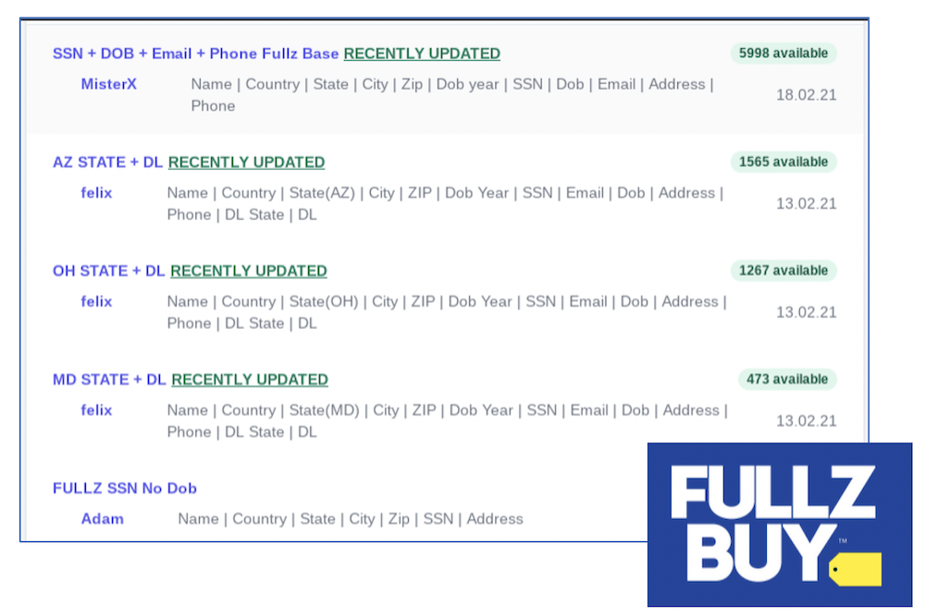
Figure 2.1 Example "fullz" captured directly from the deep web site, Fullz Buy.

Literature that reviews criminal activity provides an empirical foundation for understanding why financial PII commands this value. In one of the earliest systematic studies of stolen data markets, Holt and Lampke (2010) analyzed threads from web forums where stolen financial information was bought and sold and found a functioning market economy in which prices varied with the quality and freshness of the underlying accounts and in which seller reputation mechanisms mirrored those of legitimate e-commerce. Hutchings and Holt (2015) extended this work through a crime script analysis of 13 English- and Russian-speaking stolen data forums, demonstrating that the market constitutes a complete criminal supply chain: the tools used to steal data, the stolen data itself, and "cashing out" services such as drops and money laundering that convert records into profit. Anderson et al. (2013) estimated the aggregate economic impact of this underground economy in the billions of dollars. Taken together, these studies establish that stolen financial PII is a mature, liquid commodity, which explains why threat actors persistently prioritize it over other data types and why its theft has proven so resistant to deterrence.
The scale of PII exposure in financial breaches is documented from various sources with increasing precision. An analysis by Lab1 (2025) of more than 141 million leaked files across approximately 1,300 breached datasets found that sensitive financial documents appeared in nearly every incident examined, comprising 41% of all exposed files. Bank statements, a direct enabler of identity fraud, appeared in 49% of incidents, and International Bank Account Numbers (IBANs), exploitable for mandate fraud and payment redirection, were present in 36% of breached datasets. As shown in Figure 2.2, these figures underscore both the pervasiveness of financial PII exposure and the high market value that drives threat actors to prioritize it as a target.
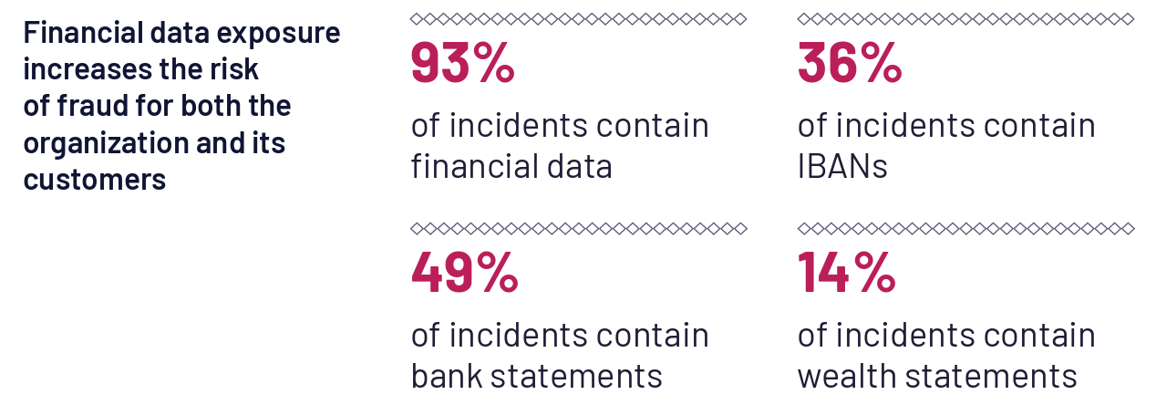
Figure 2.2 Lab1's research study shows the dangerous financial data and file exposure in cyber security incidents

Among the various forms of financial fraud enabled by PII theft, credit card fraud remains the most frequently reported. The FTC recorded approximately 503,450 credit card fraud cases in the first three quarters of 2025 alone (Caporal, 2026). This is an increase of nearly 180,000 cases over the same period in the prior year, reflecting an accelerating trend that underscores the urgency of improved detection frameworks (Caporal, 2026).
While this body of research thoroughly documents the scale, market value, and consumer consequences of financial PII theft, its focus is largely on the criminal economy and on victim impact after data has already been stolen. Far less attention has been paid to how this knowledge could be operationalized defensively, for example, by using the known monetization value of specific data types to inform how a SOC prioritizes the alerts that involve them. The significance of that omission is underscored by IBM Security and Ponemon Institute's (2025) finding that customer PII was the most frequently compromised data type, present in 53% of the breaches studied. In other words, the data type that the literature shows attackers most consistently pursue is precisely the data type for which detection workflows lack dedicated context, and it is this disconnect that the present research is designed to address.

2.3 Common Attack Vectors Used by Threat Actors
When it comes to cybersecurity attacks and identity theft for financial fraud that involves stealing PII, across different literature and analysis, it is clear that threat actors primarily use phishing, malware, or data breaches to drain accounts, open new fraudulent credit lines, or commit tax fraud (U.S. Federal Bureau of Investigation [FBI], 2025).
Large annual industry datasets corroborate this characterization and provide an empirical baseline for the attack vectors reviewed in this section. Verizon's (2025) Data Breach Investigations Report, which analyzed more than 22,000 incidents including over 12,000 confirmed breaches, found that credential abuse (22%) and the exploitation of vulnerabilities (20%) were the leading initial access vectors, that the human element was present in roughly 60% of breaches, and that ransomware appeared in 44% of breaches. Mandiant (2025), drawing on its global incident response caseload, similarly identified exploits (33%) and stolen credentials (16%) as the most common initial infection vectors and reported that the financial sector was the single most targeted industry, accounting for more than 17% of its investigations. The convergence of these independent datasets supports the conclusion that PII-focused attacks are multi-stage campaigns that nonetheless begin with a small, well-understood set of entry techniques, each of which is examined below.

2.3.1 Phishing and Social Engineering
Phishing remains one of the most prevalent and cost-effective methods for harvesting PII on a large-scale basis. The research on phishing shows a fairly standard pattern that leads to a successful data breach. To start, threat actors send deceptive emails that impersonate trusted brands, such as banks, payment processors, tax authorities, or healthcare providers, all to lure victims into providing login credentials, Social Security numbers, or financial account details. Spear phishing elevates this technique by tailoring messages to specific individuals using publicly available information gathered from social media, LinkedIn, or prior breach data, dramatically increasing the likelihood of success.
Vishing (voice phishing) and smishing (SMS phishing) extend the same deception to phone calls and text messages respectively, often targeting elderly individuals or employees who may be less familiar with these attack formats. Business Email Compromise (BEC), a sophisticated form of social engineering, involves compromising or spoofing executive email accounts to authorize fraudulent wire transfers or redirect payroll deposits, costing U.S. businesses billions of dollars annually. Research from the FBI's Internet Crime Complaint Center (IC3) consistently ranks BEC among the top financial cybercrime categories by total losses (U.S. Federal Bureau of Investigation, 2025).

2.3.2 Malware and Credential Theft
Malware deployed against individuals and financial organizations takes many forms, each optimized for a specific stage of the attack lifecycle. Keyloggers silently record every keystroke on an infected device, capturing usernames, passwords, PINs, and answers to security questions. Infostealers, a class of malware, automatically harvest saved browser credentials, session cookies, autofill data, and cryptocurrency wallet files before exfiltrating the collected data to attacker-controlled infrastructure. These tools are widely available through Malware-as-a-Service (MaaS) platforms on dark web forums, lowering the technical barrier for entry-level cybercriminals.
Banking trojans such as Emotet, TrickBot, and Dridex represent a more sophisticated category of financial malware. These threats are designed specifically to intercept online banking sessions, inject fraudulent web content into legitimate bank portals, and redirect transactions without triggering visible alerts to the victim. Once installed, they can also function as loaders by deploying additional payloads such as ransomware or remote access tools (RATs) and enabling threat actors to pivot from credential theft to full network compromise.

2.3.3 Data Breaches and Large-Scale PII Exfiltration
Large-scale data breaches represent the most impactful avenue for mass PII acquisition. Research and analysis of well-known large-scale attacks shows that threat actors targeting financial institutions, healthcare systems, and government databases can exfiltrate millions of records in a single operation, providing rich datasets that combine names, addresses, dates of birth, Social Security numbers, financial account details, and employment history. This aggregation allows for highly credible identity fraud, since the attacker can answer knowledge-based authentication (KBA) questions with precision.
Initial access to target systems is commonly achieved through exploitation of unpatched software vulnerabilities, compromised third-party vendor credentials, or brute-force attacks against externally exposed services such as Remote Desktop Protocol (RDP) or Virtual Private Network (VPN) gateways. Once inside a network, threat actors move laterally using legitimate administrative tools, a very difficult to detect technique known as "living off the land", to avoid triggering security alerts. Privileged access to databases containing customer PII is then leveraged to exfiltrate data quietly over extended periods. The empirical evidence on detection timelines reinforces how effective this quiet approach remains: IBM Security and Ponemon Institute (2025) reported that the average breach took 241 days to identify and contain, and Mandiant (2025) found that 57% of compromises were first identified by an external party, such as law enforcement or the attackers themselves, rather than by the victim's own security team. Both findings indicate that exfiltration campaigns routinely outlast the defender's detection window.

2.3.4 The Evolution of Ransomware: From Encryption to Double and Triple Extortion
While many associate Ransomware with collecting funds from encrypted data, the reality is that it has undergone a dramatic strategic evolution since the early days of indiscriminate campaigns that simply encrypted files and demanded small Bitcoin payments for decryption keys. Based on several research articles and papers, the next several sections discuss the evolution of ransomware that is relevant to data theft of PII. Ransomware operations are now highly organized, often structured as Ransomware-as-a-Service (RaaS) enterprises with dedicated development teams, affiliate networks, negotiation specialists, and even customer support portals for victims. However, the important change is that most threat actors will start with theft of PII before encryption even occurs. With its high regulatory exposure, operational dependency on continuous data availability, and repositories of sensitive PII, the financial services sector has become a primary target.
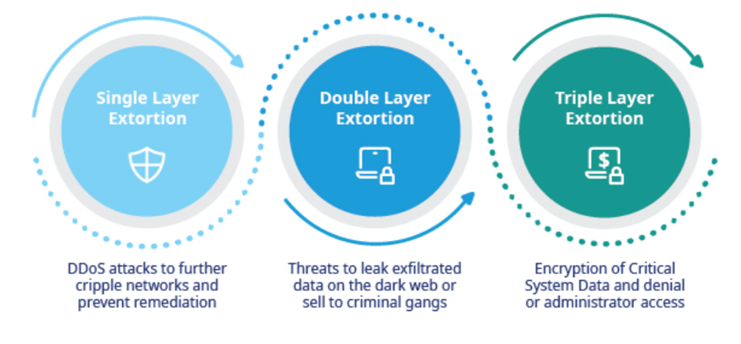
Figure 2.3 Evolution of Ransomware from Encryption to more advanced monetary gains

2.3.5 Encryption-Only Ransomware
As Figure 2.3 shows, ransomware has evolved over time. Early ransomware such as CryptoLocker (2013) and WannaCry (2017) operated on a straightforward model: infect a system, encrypt files, and demand payment for decryption. Victims who maintained current backups could often recover without paying, which drove down ransom conversion rates and forced threat actors to rethink their leverage model. This phase, while financially damaging in aggregate, did not typically involve the deliberate theft and weaponization of sensitive data.

2.3.6 Double Extortion – Steal First, Encrypt Second
The introduction of double extortion, widely attributed to the Maze ransomware group around 2019–2020, fundamentally altered the threat landscape. Rather than moving immediately to encryption, threat actors began conducting extensive reconnaissance within compromised networks to identify and exfiltrate the most sensitive data before deploying the encryption payload. This sequencing is deliberate: by stealing data first, attackers ensure they retain leverage even if the victim restores backups.
For financial institutions, this pre-encryption exfiltration phase is particularly damaging. Threat actors specifically seek out high-value PII repositories: customer account records, loan applications, know-your-customer (KYC) documentation, Social Security numbers, tax identification records, credit histories, and internal employee HR files. These datasets are especially attractive because they can simultaneously be used to extort the victimized institution and the data can be monetized independently through sale on dark web marketplaces or deployment in follow-on identity theft campaigns.
Groups such as LockBit, BlackCat (ALPHV), Cl0p, and BlackBasta have refined this approach into an industrialized workflow. After gaining initial access, frequently through phishing, exposed RDP, or exploitation of vulnerabilities in internet-facing systems, they deploy tools such as Cobalt Strike, Rclone, and MEGAsync to identify and quietly transfer terabytes of sensitive data to attacker-controlled cloud infrastructure over days or weeks. Only once data exfiltration is complete do they trigger the encryption payload, maximizing both disruption and extortion leverage.

2.3.7 Triple Extortion and Regulatory Weaponization
More recently, threat actors have adopted triple extortion tactics that layer additional pressure on top of data theft and encryption. In this model, attackers simultaneously threaten to: (1) publish stolen data publicly on dedicated "leak sites" hosted on the dark web; (2) notify or directly contact the affected institution's customers, partners, or regulators about the breach; and (3) launch distributed denial-of-service (DDoS) attacks against the victim's public-facing infrastructure to compound operational disruption.
For financial institutions, the regulatory repercussions of this threat can be very severe. A breach involving customer PII triggers mandatory notification requirements under frameworks such as the Gramm-Leach-Bliley Act (GLBA), the New York Department of Financial Services (NYDFS) Cybersecurity Regulation (23 NYCRR 500), and various state-level breach notification laws. Threat actors have begun explicitly threatening to report victims to regulators if ransoms are not paid, recognizing that the prospect of regulatory fines, reputational damage, and class-action litigation amplifies pressure on victim organizations to comply. The Cl0p group's exploitation of the MOVEit Transfer vulnerability in 2023, which compromised PII held by hundreds of financial institutions, government agencies, and service providers globally, exemplified this approach at unprecedented scale.

2.3.8 Targeting Financial Institutions: Why PII is the Primary Objective
When examining literature that discusses major breaches, what stands out is that financial institutions hold a uniquely rich concentration of PII that makes them disproportionately attractive ransomware targets. For example, unlike retail or healthcare targets, banks and credit unions possess data that is simultaneously personally identifying, financially actionable, and legally regulated, a combination that maximizes both the operational disruption of encryption and the extortion value of exfiltrated records. A single stolen customer record from a financial institution may contain a full name, physical address, date of birth, Social Security number, account numbers, routing numbers, credit score, transaction history, and beneficiary information. This data would easily be sufficient to commit identity fraud across multiple financial products.
The interconnected nature of the financial sector further amplifies risk. Core banking platforms, payment processors, and third-party service providers often share access to customer data across institutional boundaries. A successful ransomware intrusion at a managed service provider (MSP) or financial technology (fintech) vendor can provide lateral access to dozens of downstream financial institutions simultaneously, as demonstrated by several high-profile supply chain attacks in recent years. This interconnectedness means that even smaller community banks and credit unions, which may have fewer dedicated cybersecurity resources, can become entry points for attacks targeting much larger financial ecosystems.
A consistent theme that emerges across both academic and industry literature is that detection research has not kept pace with this shift toward data theft. In a systematic review of 212 academic ransomware studies published between 2020 and 2023, McIntosh et al. (2024) found that the majority continued to focus on the file-encryption behavior of early crypto-ransomware, often using samples that predate the data extortion era, and that very few addressed exfiltration-led double extortion at all, leading the authors to call for a realignment of ransomware research with current industry threats. Empirical work supports the urgency of that call: in a forensic analysis of 124 ransomware attacks between 2019 and 2022, Meurs et al. (2022) found traces of data exfiltration in 43% of cases. If both academic detection research and SOC tooling remain oriented toward the encryption event rather than the theft of sensitive data that precedes it, then the exfiltration phase, which is the phase in which PII context would be most diagnostic, remains the least defended. With that gap in mind, the following sections examine the organizational and technological capabilities that financial institutions have developed in response to this threat landscape.

2.4 Major Breaches That Have Targeted PII in Financial Institutions
Financial data breaches represent a significant failure in the "social contract" between institutions and consumers. When PII is compromised, there is certainly potential financial impact to the consumer, there are typically multi-year costs related to remediation, loss of brand reputation, increased security spending, legal costs and/or government fines. However, there is also a deeper impact on the overall organization in terms of potential layoffs due to unplanned costs that can also be possible (Tran et al., 2024).
The financial consequences of breaches have been studied empirically for more than two decades. Early event studies found that breach announcements produce negative abnormal stock returns, with the effect concentrated in incidents involving confidential information (Campbell et al., 2003), and that the magnitude of the market penalty varies with firm and breach characteristics (Cavusoglu et al., 2004). This literature established that breaches involving sensitive personal data are economically distinct from other security incidents, a finding that anticipates the central premise of this study: that data sensitivity should similarly distinguish how security events are prioritized before a breach completes, not only how its damage is measured afterward.
Industry benchmarks for the financial sector suggest an average cost of $6.08 million per incident for smaller breaches, but for multi-million record exposures, costs typically scale based on a $168 - $264 per-record cost in the U.S. For example, for just 5 million records, that is in the range of $840M all the way to $1.32B (IBM Security & Ponemon Institute, 2025).
In preparation for focusing on specific attacks that were used, this section reviews some high-profile attacks that successfully targeted financial institutions and, in most cases, had major financial impact that was quantifiable to a degree.
Below is a breakdown of the documented and estimated financial impacts for these major breaches.

2.4.1 First American Financial Corp
The massive data exposure at First American Financial, first reported by Brian Krebs (2019), occurred through simple URL harvesting, where approximately 885 million sensitive records, including Social Security numbers, bank account details, and wire transfer instructions became accessible to anyone without requiring a password or further authentication (Institute of Data, 2024).
Relevance to Data Security and SOC Operations
This data breach shares common themes with the TransUnion breach of 2025, in which attackers accessed a third-party consumer-support application and exposed the PII of approximately 4.5 million individuals (Ben-Ari, 2025). Both were the result of "context failure". In both cases, the Data Security teams took appropriate steps to set up (Application Programming Interfaces (APIs) to share data with the SOC, but they never explained the logic or relevance of the data sent. So, when an attacker started "scraping" millions of records by changing ID numbers in the URL, a technique formally classified as broken object level authorization (OWASP, 2023), the SOC's tools likely saw a high volume of traffic. Certainly, as a behavioral event, this may have seemed a red flag, but relatively minor with no additional context. Without a "baseline" from the Data team explaining what normal user behavior looks like, the SOC dismissed the traffic as "standard heavy load" or "system testing." However, the SOC also lacked important context like whether data being targeted was sensitive data or where it was stored. Both elements communicated and combined with a SOC framework for PII could have increased the severity of the event without the need for the Data Security to keep and communicate an updated list of logic rules.
Unfortunately, the result was a massive exfiltration that occurred in plain sight because the SOC lacked the "Data Context" to recognize a logic abuse (BOLA) as a theft in progress.

2.4.2 Equifax Breach
Although a fix had been available for months, Equifax's dispute portal remained unpatched, allowing attackers to exploit a Remote Code Execution (RCE) bug where specially formatted web requests were misinterpreted as executable commands (Fernandez, 2025; Thiyagarajan et al., 2025). This kind of security lapse left the sensitive data of 147 million individuals, including names, Social Security numbers, and birth dates, exposed to unauthorized access. The financial and legal repercussions were unprecedented, involving a $700 million settlement and total costs exceeding $1.4 billion, which included a decade-long commitment to provide free credit monitoring for all affected consumers (U.S. Federal Trade Commission, 2024).
Relevance to Data Security and SOC Operations
The data security team knew about the Apache Struts vulnerability, CVE-2017-5638 (Common Vulnerabilities and Exposures Database, 2024). However, there was a breakdown in communicating the "criticality" to the teams responsible for the servers to put that patch at the top of the list. The SOC, meanwhile, wasn't told to prioritize monitoring for "Struts-based" exploit attempts while the patch was pending. As a result, a known hole remained open. Once again, an unusual activity paired with PII context, could have indicated to the SOC team that "business was NOT going on as usual", regardless of being un-informed of the severity of this specific exploit. As the goal here is to show that the SOC can use a PII framework to classify and identify sensitive data upfront, and correlate that to seemingly low-criticality events, it can elevate the risk to a more accurate priority as a potential attack.

2.4.3 Heartland Payment Systems
The Heartland Payment Systems breach stands as one of the most significant instances of a SQL injection attack, where hackers exploited un-sanitized input fields to bypass standard security and issue direct commands to the company's databases (Cingolani & Zamparini, 2019). This massive exposure resulted in monumental financial consequences for Heartland, particularly in the form of reimbursements to major credit card brands like Visa, MasterCard, and American Express. The company ultimately paid approximately $110 million to these providers to cover the costs of fraudulent transactions and the widespread re-issuance of compromised cards, highlighting the extreme risks inherent in payment processing vulnerabilities (McGlasson, 2010).
Relevance to Data Security and SOC Operations
In this attack, the data security team failed in its fundamental responsibility to enforce secure coding practices and input validation, leaving the "front door" vulnerable to an SQL injection that allowed attackers to bypass authentication and gain direct database access. Because the input was not sanitized, the database executed malicious commands that authorized the installation of "sniffing" malware across the payment processing environment. This created an impossible situation for the SOC, as the initial breach occurred through a standard web port (Port 80/443) that appeared as legitimate traffic. However, despite using a standard and legitimate web port to communicate, what would have helped the SOC would have been identifying where databases were being targeted that happened to contain sensitive data. Any unusual activity logged by the database software, such as a large transfer of sensitive data, would have been correlated to this information and potentially escalated the severity of the communications and subsequent attempts at exfiltration of PII.

2.4.4 Capital One
The 2019 Capital One breach was an example of a targeted cloud attack. It was executed through a sophisticated Server-Side Request Forgery (SSRF) attack, where a former Amazon Web Services (AWS) employee exploited a misconfigured WAF to infiltrate the bank's cloud infrastructure. This was one of the high-profile attacks that led to data security concerns in the cloud, especially when it came to tracking and misconfiguration of dynamic storage (Skelton, 2021). The fallout from this incident was significant, resulting in an $80 million fine from the OCC for inadequate cloud risk assessment and a subsequent $190 million class-action settlement to compensate affected individuals for their losses. (Ennis, 2023).
Relevance to Data Security and SOC Operations
In this attack, the Data teams (engineering and security) spun up new cloud environments (S3 buckets, RDS databases) for testing or scaling without informing the SOC. The SOC was unable to identify the cloud storage by itself, leaving these assets and corresponding data blind to them. This problem is often referred to as "shadow data" (Rodriguez, 2025). Essentially, SOC cannot monitor what they don't know exists. Even if the SOC received an event of some sort suggesting a resource was "private" and flipped to "public", which is often an indicator of a new vulnerability or active attack, the lack of asset inventory knowledge of the SOC or that data exists on that asset would potentially not make this alert a high enough priority despite the risk. The result is that the PII sits on the open web for months because the people whose job it is to watch the critical assets didn't know they existed or possibly moved.

2.4.5 Desjardins Group
The Desjardins breach represents a severe instance of a currently emerging threat that has grown significantly in the last several years, insider threats (Akinsola et al., 2025; Cybersecurity and Infrastructure Security Agency, 2017). This internal theft led to the systematic scraping of records, ultimately compromising the personal information of 9.7 million members—the company's entire individual membership base at the time (Office of the Privacy Commissioner of Canada, 2020). The fallout for the Canadian cooperative was immense, resulting in a $201 million (CAD) class-action settlement and a mandate to provide permanent security and credit monitoring for affected members, given that highly sensitive identifiers like Social Insurance Numbers were permanently compromised (The Canadian Press, 2021).
Relevance to Data Security and SOC Operations
The Desjardins breach serves to illustrate the risks associated with malicious insider threats and the failure of data security teams to enforce the principle of least privilege. This failure resulted from a lack of robust internal monitoring and role-based access controls. From the SOC perspective, because the employee was using legitimate, though over-privileged with administrative credentials, the SOC's monitoring tools likely viewed the data access as "authorized" rather than suspicious. This lack of integrated defense meant that while the data security team left the "internal doors" unlocked, the SOC was not equipped with the context to know that someone was accessing critical PII, which would have been a severity alert, even as the entire company's database was being exfiltrated.

2.4.6 JPMorgan Chase
The 2014 JPMorgan Chase data breach bypassed the bank's standard security layers and led to an exposure comparable to cloud misconfigurations where private data is accidentally left public. In this instance, the breach compromised the names, addresses, phone numbers, and emails of 76 million households (Jeng, 2015). The bank incurred tens of millions of dollars in legal fees defending against various class-action lawsuits (Raghu, 2020).
Relevance to Data Security and SOC Operations
In the case of JPMorgan Chase, the Data teams logged everything and sent it to the SOC (the SIEM). However, as typical of many SOC teams, they are overwhelmed by the number of alerts being received and chasing down False Positives (Tariq et al., 2025). In this case, the logs would have exposed the fact that a lack of Multi-Factor Authentication (MFA) was configured properly on one server. The log likely showed a weird login from an unrecognized IP. This is a perfect example of not knowing that highly sensitive PII was contained on that particular asset because the SOC and the Data Architects had no way to establish that the event posed a greater risk, and that the specific login event was buried under 100,000 other meaningless alerts. Effectively, The SOC "saw" the breach in the logs but didn't realize it because they didn't know which specific servers held the critical PII, which was both a location stored and classification failure.
Viewed collectively, these six cases align closely with the broader empirical literature on detection failure. Government post-mortems of the Equifax breach concluded that the incident was preventable and attributed it to identifiable failures in patch management, certificate management, and internal communication between data owners and security operations (U.S. Government Accountability Office [GAO], 2018; U.S. Senate Permanent Subcommittee on Investigations, 2019), failures that recur in some form across each case reviewed here. The pattern is also consistent with industry-wide measurements: Mandiant (2025) reported that 57% of compromises were first discovered by external parties rather than internal security teams, and IBM Security and Ponemon Institute (2025) found that the average breach lifecycle still spans 241 days. What the case-study and post-incident literature has not produced, however, is an operational framework that translates knowledge of where sensitive PII resides into the SOC's alert triage workflow. Each set of research simply ends up recommending better communication between data and security teams but stops short of specifying how this can be effectively accomplished. This is exactly what this praxis research targets, and the following sections review the two disciplines, data security posture management and security operations, whose integration it requires.

2.5 Data Security Posture Management (DSPM)
In the early days of cloud migration, security teams started to recognize a large visibility gap in terms of where and how data was stored. Cloud migration introduced several layers of complexity that made tracking data at rest significantly more difficult than in traditional on-premises environments (Komal & Madan, 2023).
For one, in the cloud data is constantly in motion and often scattered across multiple cloud platforms or vendors and on premise (typically a mix is called hybrid cloud). This is typically done for performance and reliability (Swanzy et al., 2024).
In addition, the advent of cloud computing and the efficiencies it brings in terms of resource allocation and usage means they can spin up and down microservices, containers, and serverless functions, making it harder to track where data is being temporarily or permanently stored.
The simplicity of spinning up resources, that can often be temporary, has also led to Shadow IT. Shadow IT, as it refers to the cloud, means unauthorized cloud subscriptions and undocumented software purchases by different business units or individuals can result in sensitive data being stored without the IT department's knowledge (Kirin, 2017).
However, misconfigurations are considered the primary cause of data breaches in cloud (InstaTunnel Engineering, 2025). The ease of provisioning new resources often leads to human errors, such as leaving storage buckets (like Amazon S3) publicly accessible, without a potential owner and untracked. In many cases, misconfigurations were also associated with poor tagging of data for classification in order to distinguish between different tiers of data based on sensitivity or criticality to the business. In financial services, this applies to PII specifically.
DSPM emerged to solve this "data blindness" by shifting the focus from infrastructure to the data itself. The term was formally introduced by Gartner in its 2022 Hype Cycle for Data Security, which defined DSPM as providing visibility into where sensitive data is, who has access to it, how it has been used, and what the security posture of the underlying data store or application is (Gartner, 2022). In practice, this meant understanding how to better protect data stored across cloud and hybrid architectures, even as that data remained in constant motion.
Similar to Shadow IT, the challenge for these teams got its own term known as "Shadow Data" (Yaacovi, 2022). Shadow data refers to data that is collected, processed, and stored without the knowledge or control of an organization's IT department. This data often resides in cloud services, personal devices, or third-party applications. While shadow data has become increasingly common with the rise of remote work and the proliferation of cloud-based tools, identifying where PII is stored and securing it has become a much greater challenge.
DSPM functions, as shown in Figure 2.4, as a high-tech librarian for the cloud. It is designed to scan massive, disparate data stores (S3 buckets, Snowflake, SQL databases) to answer three critical questions: Where is the data? What is it? Who can see it? (Strange, 2024).
- Discovery and Classification: It uses AI and pattern matching to identify PII.
- Vulnerability Mapping: It identifies "shadow data". This is in the context of users or systems creating backups or copies of databases that aren't monitored often with no limitations on or improperly set permissions and access controls.
- Risk Prioritization: By knowing a database containing 10,000 credit card numbers, it helps teams prioritize fixing a misconfiguration there over a database containing public marketing assets.
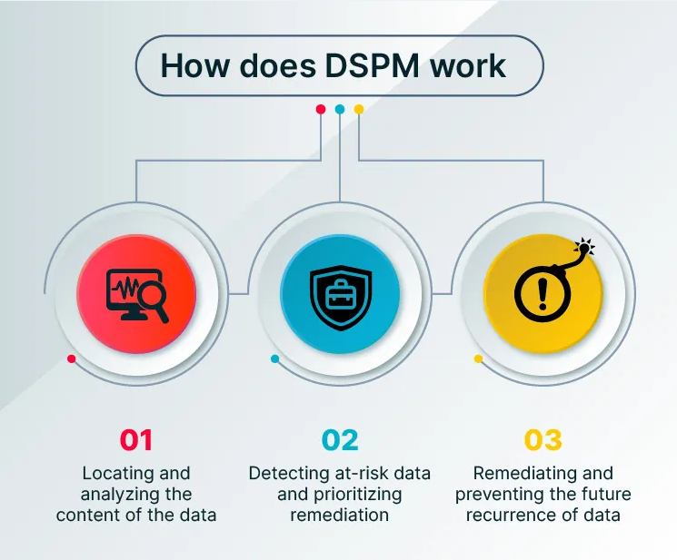

Figure 2.4 What Is Data Security Posture Management (DSPM)? Retrieved from aquasec.com. Cited in Strange (2024).

While DSPM is a powerful tool when it comes to improving data protection and governance, it rarely operates in real-time and the way it does scanning simply determines the state (location, access rights, encrypted, classification, criticality) of the data. In some cases, it can take steps to improve the security posture of the data automatically, but neither the data security and governance teams that use DSPM are focused on active threats or inappropriate access of that data.
DSPM tells the data security team that the data is sensitive, but it often lacks the runtime context. If a developer suddenly accesses a production database, the DSPM tool knows the database is sensitive, but it doesn't necessarily know that the developer's credentials were just compromised on a separate endpoint. However, this is where the SOC comes into play, as it can correlate disparate events to stop a breach in progress.
It is also notable that the DSPM literature remains predominantly practitioner-driven, consisting largely of analyst research and vendor publications (e.g., Gartner, 2022; Strange, 2024), while peer-reviewed treatments of cloud data security (Komal & Madan, 2023; Swanzy et al., 2024) address discovery, classification, and governance but generally treat posture management and threat detection as separate problems. Neither set of literature proposes a mechanism for feeding DSPM-derived data classifications into the SIEM's correlation and triage logic in real time, which is precisely the integration this study investigates. The next section turns to the literature on the SOC, the organizational function on the other side of that divide.

2.6 The Role of the SOC
The Security Operations Center (SOC) has evolved from its origins as a network traffic monitoring function into the organizational hub for enterprise-wide threat detection, investigation, and response. The SOC operates as a continuous 24/7 function, integrating people, processes, and technology to monitor security posture and respond to incidents across the full infrastructure environment (McDonald, 2025). Its defining characteristic is centralization: by aggregating telemetry from across an organization's environment, the SOC provides the unified visibility necessary to identify and act on threats that would otherwise remain hidden within siloed systems.
The SOC is typically implemented in more mature organizations that can support an organization-wide security monitoring program with security analysts and incident responders when a cyber security threat to the organization is determined. It acts as centralized monitoring hub for security analysts that first and foremost collects log events from across an organization's IT infrastructure, including networks, devices, appliances, and information stores and monitors interest events for signs of a threat. Traditionally, as specific events are identified of interest, the security analyst will further investigate these events using additional tools or connecting directly to other security systems (Microsoft Corporation, n.d.).
As the SOC is the central hub for monitoring, detecting and responding to threats, the SIEM has become the central technology within the SOC itself. The SIEM is responsible for aggregating, normalizing, and analyzing log data from across an organization's IT infrastructure, allowing SOC analysts to identify and respond to threats based on the fact that logs can typically be collected from every system to paint a picture of its state (Miloslavskaya, 2018).
The following is a breakdown of the key components of the SIEM in supporting the SOC as the central tool for threat detection, investigation and response (AmpcusCyber, 2026).
- Central Data Hub & Visibility: The SIEM is the primary repository for log data from diverse sources, including firewalls, endpoints, cloud services, and identity providers. It converts massive, noisy data sets into a unified, actionable view.
- Correlation and Alerting: The first set and core set of analytics provided by the SIEM links disparate, isolated data points to detect complex or stealthy cyberattacks in real-time. The primary source of data that is correlated is log data. Sometimes the SIEM's primary set of analytics are referred to as log analytics for this reason, and typically that means log correlation. It is the most rudimentary form of analytics and is often just referred to as correlation. From this correlation, alerts can be raised once simple patterns are recognized.
- Compliance & Reporting: The original reason why many organizations purchased a SIEM before leveraging for security purposes despite the acronym including "Security", was for meeting regulatory requirements (e.g., GDPR, HIPAA, PCI DSS) through log retention and the ability to generate reports from these logs. Many regulations maintaining activity or state of systems and log collection and retention are clearly the primary strength of the SIEM.
- Accelerating the job of the security analyst: While the SOC provides human expertise, the SIEM reduces the cognitive overload ("alert fatigue") for analysts by prioritizing true threats over false positives. Truth be told, this capability evolved over time from simple collection to log correlation. Since then, many SIEMs have added analytical engines side-by-side with the core log analytics capability (e.g. UEBA) and even newer generations of SIEMs have tried to re-architect the SIEM to move away from just logs and incorporate other types of telemetry beyond just log data. Certainly, the addition of machine learning (ML) and Artificial Intelligence (AI) has also accelerated the way SIEM's process alerts, helps with threat detection, accelerate investigations and prioritize response (Bhatia, 2025). Figure 2.5 describes a SOC workflow with the SIEM being the primary tool used for the listed states.

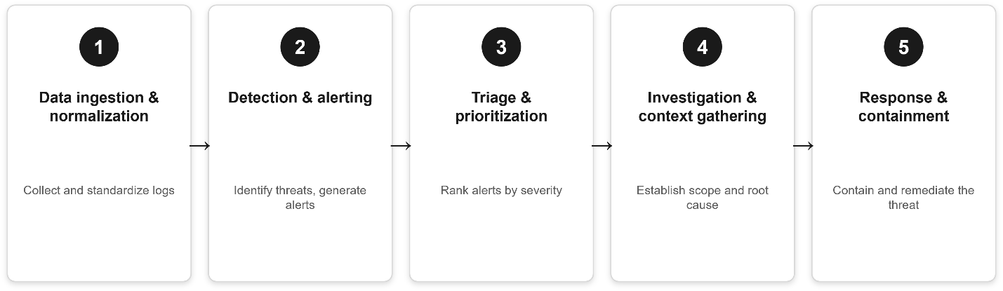
Figure 2.5 The SOC workflow enabled by the SIEM.

2.7 The SOC Flow: From Signal to Action
Effective security operations is best understood as a pipeline that begins with collecting and making sense of massive volumes of raw telemetry and ends with decisive action to contain and eradicate threats before they cause serious harm.
Based on various research that discusses the inner workings of the SOC, the following sections walk through each phase of the SOC operational flow with the SIEM being at the core. This flow spans data ingestion and normalization, through detection, triage, prioritization, and investigation, to containment, eradication, and the post-incident review cycle that closes the loop and drives continuous improvement (Akula, 2024). Figure 2.6 elaborates further from Figure 2.5 to illustrate SOC operations powered by the SIEM. The role of event data and the context provided to the SOC is worth emphasizing, because it remains the primary source of truth despite the evolution of other technologies that provide context and analytics to the SOC beyond the function of the SIEM.
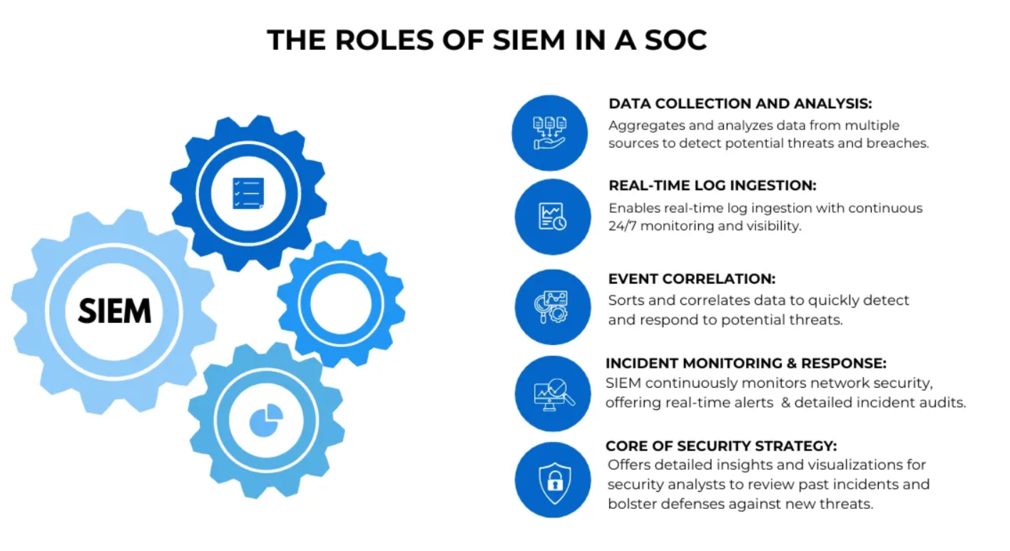
Figure 2.6 The Role of the SIEM in a SOC. From "CloudifyOps: Security Operations Center," by Akula, V. (2024), Medium. https://medium.com/@cloudifyops

2.7.1 Data Ingestion & Normalization
A SOC's effectiveness begins with the breadth and quality of its data collection. Telemetry is ingested from virtually every corner of the environment. A good description of the types of telemetry comes from a glossary available from Deepwatch: "telemetry encompasses multiple data types, including system logs (e.g., Windows Event Logs), application logs (e.g., API access logs), network telemetry (e.g., NetFlow, Domain Name Services (DNS)), and identity telemetry (e.g., Single-Sign-On (SSO) events, Multifactor Authentication (MFA) logs)" (Deepwatch Inc., 2026). Common sources include Endpoint Detection and Response (EDR) agents, firewalls, load balancers, cloud APIs, and SaaS platforms. All of this raw, heterogeneous data is shipped, typically using syslog, vendor APIs, often using the Representational State Transfer API, commonly referred to as REST API, or lightweight forwarders into a centralized SIEM or data lake, where it is parsed, normalized into a common schema, such as the Elastic Common Schema (ECS) (Brahmam, 2023; Elastic N.V., 2026d), timestamped, and indexed for search. This is typically where many SIEM solutions have custom rules or filters, often referred to as a data pipeline.

2.7.2 Detection & Alerting
Once data is flowing and normalized, the SIEM applies detection logic continuously across the incoming stream. This includes signature-based correlation rules (e.g., "alert if a user authenticates from two geographically impossible locations within 10 minutes"), threshold-based rules (e.g., "alert on more than 50 failed logins in 5 minutes from a single host"), and increasingly, ML-driven behavioral baselines that flag deviations from a user or entity's normal pattern, which commonly referred to as UEBA (User and Entity Behavior Analytics) (Nagaraj, 2023). On top of SIEM-native detections, dedicated tools like an NDR (Network Detection and Response) platform analyze east-west traffic for command-and-control beaconing or lateral movement, while EDR platforms surface on-endpoint detections such as credential dumping, process injection, or living-off-the-land techniques (Yusuf, 2022). Each fired detection generates an alert, tagged with metadata including the triggering rule, affected assets, timestamps, and where possible, a preliminary MITRE ATT&CK tactic and technique mapping (MITRE Corporation, 2026). The output of this layer is a queue of alerts, which ranges from tens to thousands per day depending on environment size and tuning maturity, all of which flows into the triage queue.

2.7.3 Triage & Prioritization
The triage stage is where Tier 1 analysts serve as the first human checkpoint, working through the alert queue to rapidly determine what warrants further attention (Zhong et al., 2017). The core task is separating true positives from false positives and noise but doing so efficiently under volume pressure. Analysts assess each alert against a set of contextual signals: Is the affected asset a crown jewel system (domain controller, payment server) or a low-value workstation? Is the user a privileged account or a standard employee? Has this exact indicator fired before and been closed as a false positive? Does the behavior align with a known business process (e.g., a scheduled vulnerability scan triggering a port sweep alert)? Security Operations, Automation and Response (SOAR) platforms play a significant role here by automatically enriching alerts the moment they are created. This is done by querying threat intelligence feeds for IP and domain reputation, pulling asset inventory data, checking whether a file hash is known-malicious via VirusTotal or an internal sandbox, and correlating the alert against any open incidents involving the same entities (Jangampet et al., 2024). Prioritization is then applied, often using a risk-scoring model that weighs asset criticality, threat confidence, and potential business impact, ensuring that a suspected ransomware precursor on a finance server jumps ahead of a low-confidence alert on an isolated dev box (Jangampet et al., 2024). Anything confirmed as noise is closed with documentation, feeding tuning efforts to reduce recurrence.

2.7.4 Investigation & Context Gathering
Alerts that survive triage are escalated into formal incidents and handed to Tier 2 or Tier 3 analysts for deep investigation (Akula, 2024). The investigator's goal is to answer a core set of questions: What exactly happened? When did it start, and how far back does the activity go? What systems, accounts, and data were involved? Is this an isolated event or evidence of a broader intrusion? Analysts pivot aggressively across data sources, starting from the initial alert and fanning out through SIEM queries, EDR telemetry, and network logs, to reconstruct a full attack timeline. A suspicious PowerShell execution on an endpoint, for example, might prompt the analyst to examine the parent process that spawned it, the network connections the host made around the same time, whether any lateral movement occurred via SMB or RDP, what credentials were in use, and whether those credentials authenticated anywhere else in the environment. Threat intelligence is layered in throughout where it maps observed TTPs to MITRE ATT&CK, cross-references IOCs against intel feeds, and checks whether the activity pattern resembles a known threat actor or campaign. The output of this stage is a clear understanding of scope: a list of confirmed compromised hosts and accounts, the likely initial access vector, the attacker's apparent objectives, and an assessment of whether the threat is still active.

2.7.5 Response & Containment
With scope established, the team shifts to active response. Immediate containment actions are taken to stop the spread and limit damage: compromised endpoints are isolated from the network (a single click in most modern EDR platforms), affected user accounts are suspended or have their credentials rotated, malicious processes are killed, and identified Command and Control (C2) domains or IP addresses are blocked at the firewall and DNS layer. If cloud infrastructure is involved, misconfigured resources are remediated, exposed API keys are revoked, and suspicious Identity and Access Management (IAM) sessions are terminated. SOAR playbooks automate many of these containment steps, enabling consistent, fast execution without relying solely on analyst memory under pressure. Beyond immediate containment, eradication follows, which typically involves removing malware persistence mechanisms (scheduled tasks, registry run keys, malicious services), reimaging heavily compromised hosts, and patching the vulnerability or closing the misconfiguration that enabled initial access. Throughout response, forensic preservation is just as important. This includes preserving memory dumps, disk images, and relevant log exports that are captured before they are overwritten, preserving the evidentiary record for any potential legal or regulatory inquiries.
A post-incident report is written capturing the full timeline, root cause, scope of impact, actions taken, and any gaps in detection or response that were exposed.

2.8 Main Challenges for the SOC
Even well-structured SOC pipelines of the type described in Section 2.7 are not immune to systemic failure. The literature identifies three categories of challenge that consistently undermine SOC effectiveness regardless of organizational maturity: excessive alert volume leading to analyst fatigue, insufficient asset and data context causing misaligned prioritization, and the structural inability to detect slow and deliberate threat actors who operate beneath detection thresholds (Bradley, 2026). Each of these challenges is directly relevant to the problem of PII-targeted attacks, and each is examined in the subsections below. The following sections walk through each phase of the SOC operational flow in detail and examine how these problems can limit the ability for the SOC team to properly identify the risk associated with an attack. Because the focus here is on the risk to PII, this section refers specifically to the effect these challenges have on the SOC team's ability to identify risks to PII, subsequently prioritize these risks and investigate them effectively all of which lead to longer response times.
While many of these SOC challenges were touched upon within each high-profile financial data breach in section 2.4, this section examines each challenge in greater depth and specifically how a PII framework can help improve SOC efficacy.

2.8.1 Too Much Noise and Alert Fatigue
When referring to Figure 2.5 and section 2.7.1, collecting data from various sources and correlating that data is one of the first stages in the SOC workflow. However, SOC teams today are frequently overwhelmed by a relentless deluge of events and security notifications, a phenomenon widely known as alert fatigue. As organizations expand their digital footprints, SIEM systems ingest massive volumes of data, often triggering thousands of alerts per day, many of which are false positives or low-priority "noise." When analysts are forced to sift through an endless queue of repetitive or insignificant warnings, their cognitive load increases, leading to burnout and decreased morale (Osholake et al., 2024). More dangerously, this saturation creates a "crying wolf" effect where critical indicators of a sophisticated breach can easily be missed or ignored amidst the clutter, significantly increasing the mean-time-to-detect (MTTD) a genuine threat.
To combat this exhaustion and prioritize effectively, SOC teams must transition from volume-based monitoring to risk-based analysis by integrating deep data context into their SIEM workflows. By automatically gathering context regarding the classification, sensitivity, and physical location of PII, analysts can instantly distinguish between a commodity malware infection on a guest workstation and a targeted exfiltration attempt on a server containing regulated customer data. Understanding exactly what data is at risk and whether it falls under strict compliance mandates like GDPR or CCPA, allows the SOC to apply a "value-at-risk" lens to every incident. This contextual intelligence transforms a generic alert into a prioritized business risk, ensuring that the team's limited time and energy are focused on the threats that pose the greatest potential for financial or reputational damage.

2.8.2 Prioritization Inhibits Threat Detection and Response
Without a baseline of data context, SOC analysts are often forced to treat all security events with equal urgency, leading to a "first-in, first-out" approach that is fundamentally disconnected from business risk. When an anomaly, for example, an unusual outbound connection or a spike in database queries, is detected, the lack of metadata regarding the target asset makes it impossible to determine if the activity is a routine administrative task or an attacker attempting to exfiltrate sensitive data (i.e. PII). This "context vacuum" forces security analysts to spend an excessive amount of time manually pivoting between disparate tools to understand what activity is actually occurring and what is being potentially targeted, often losing the race against an attacker who is moving laterally through the network (Zeitlow, 2026).
When PII classification and sensitivity are integrated into a contextual framework, the SOC can move toward automated, high-fidelity prioritization. By correlating anomalies against the specific attributes of the data at risk, the SIEM can dynamically adjust the risk score of an event. For example, a suspicious login attempt on a generic workstation might trigger a low-priority alert, whereas the same behavior on a server tagged with "High-Sensitivity PII" or "Regulatory Target" would immediately escalate to a critical incident. This allows the system to distinguish between a technical anomaly and a potential data catastrophe by factoring in the "weight" of the target.
Ultimately, this framework enables a more surgical response by aligning security operations with data governance. By identifying the targets that hold the most sensitive PII, the SOC can prioritize investigations based on a calculated risk score that accounts for both the severity of the threat and the value of the asset. This approach ensures that limited investigative resources are always directed toward events where the potential for a data breach is highest, effectively turning the SOC from a reactive monitoring unit into a risk-aligned defense team.

2.8.3 The Slow and Silent Attacker Is The Most Dangerous
When a SOC team lacks data context, they are forced to operate in a "reactive vacuum" where security events appear as a fragmented, flat list of technical anomalies. Without knowing which assets house sensitive PII, an analyst might see a series of failed logins or an unusual API call and dismiss them as routine network noise or a misconfigured service. This lack of prioritization means that the "signal" of an actual PII theft, such as a small but unauthorized data egress from a legacy database, is frequently buried under thousands of low-risk alerts. By the time the SOC can manually connect these dots, the attacker has often already identified the "crown jewels" and completed the exfiltration, leaving the team to investigate a disaster that has already occurred.
The danger of missing these critical events is that modern attackers do not need to trigger "loud" alarms to be successful; they simply need to find the gaps where context is missing. If a SOC cannot see that a specific user account has suddenly accessed a high-sensitivity PII bucket it has never touched before, the event may never reach the threshold for a manual investigation. This "context gap" essentially provides a cloaking device for intruders, allowing them to dwell within the environment for weeks or months, often referred to as attack dwell time (Sloan, 2025). Because the SOC is unable to prioritize based on the classification and location of data, they remain blind to the fact that a minor technical anomaly is actually part of a broader attack campaign against the organization's most regulated information.
This failure to bridge the gap between technical alerts and data sensitivity is precisely what led to one of the most significant PII breaches in the financial industry: the 2019 Capital One breach. Because the SOC lacked the integrated context to realize that a single IAM role had over-privileged access to more than 700 S3 buckets containing sensitive PII, the unauthorized access went undetected for months. This massive breach underscores that without a contextual framework to flag anomalies involving PII targets, even the most sophisticated financial institutions can allow a catastrophic attack to slip through their defenses.

2.9 MITRE ATT&CK Framework as a Cornerstone of Security Operations
The MITRE ATT&CK (Adversarial Tactics, Techniques, and Common Knowledge) framework serves as a foundational catalog for the SOC in systematically categorizing, analyzing, and relating the specific security events that analysts encounter and showing them how it relates to the overall attack campaign by a threat actor (MITRE Corporation, 2026). As Figure 2.7 illustrates, instead of treating each security alert as an isolated incident, the ATT&CK framework enables analysts to map observed behaviors, such as a PowerShell execution, an anomalous outbound connection, or an unusual database query, to a documented set of adversary tactics and techniques. By providing this reference it can reveal to analysts the underlying intent and progression of an attack in progress. This is especially critical when analyzing threats targeting the exfiltration of credit card and banking transaction data from financial institutions, where threat actors routinely execute multi-stage campaigns that span weeks or months before a single high-confidence alert is generated.

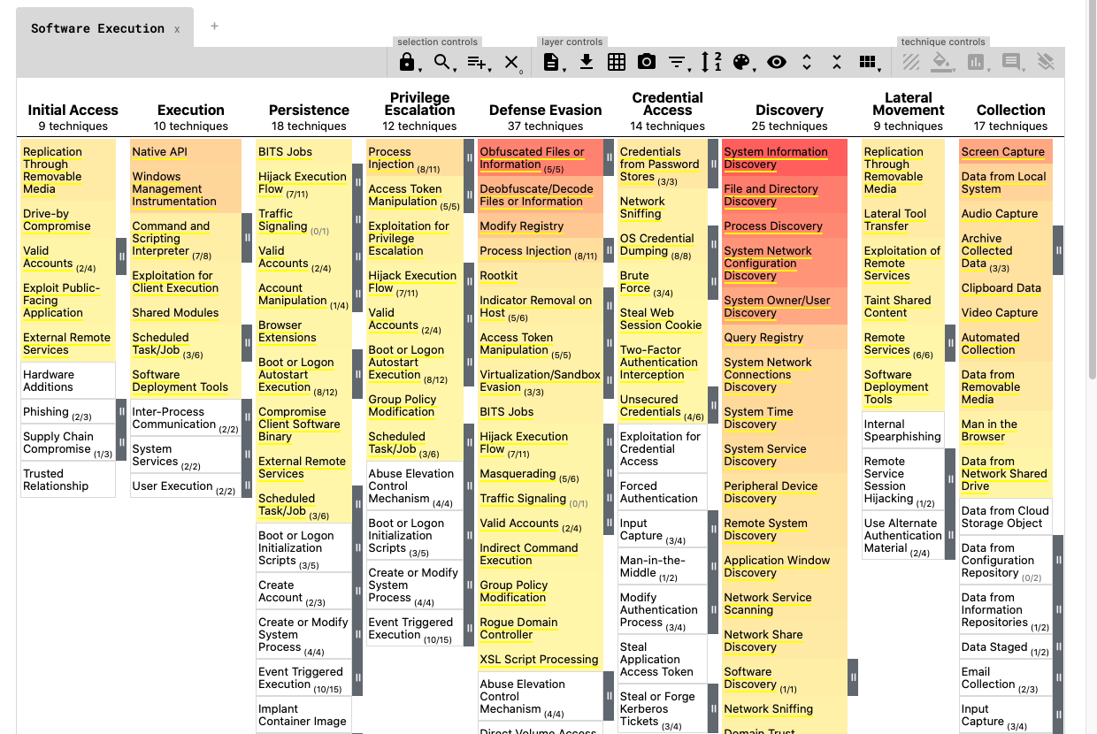
Figure 2.7 MITRE ATT&CK Framework Navigator Tool example used by SOC to identify attacker tactics

The five attack scenarios used to illustrate the basis of this research show how referencing the ATT&CK framework can help reveal how isolated, low-context events by themselves can benefit the analyst. However, by bringing in PII context, this can significantly augment the prioritization of these events sooner in the attack chain.
In Scenario 1, a Remote Access Trojan (RAT) campaign begins with a spear-phishing delivery (T1566.001) and progresses through persistence via registry Run key modification (T1547.001), PowerShell-based file system discovery targeting SSN and bank account files (T1083, T1005), and ultimately staged exfiltration over a Command-Control (C2) channel (T1074.001, T1041) — a sequence where each alert, viewed in isolation, may appear unremarkable, but when mapped through ATT&CK reveals a complete APT-style campaign targeting Tier 1 PII.
In Scenario 2, a credential harvesting and account takeover campaign exploits phishing to capture online banking credentials (T1566.002), followed by anomalous authentication from new geographic locations (T1078) and session token theft (T1539, T1185), techniques that, when correlated through the ATT&CK lens, connect a seemingly routine failed login to an active financial account compromise.
Scenario 3 demonstrates that the ATT&CK framework is equally essential for insider threats: a privileged user conducting bulk database exports of full customer records, including SSNs, account numbers, and credit histories, maps to legitimate credential abuse (T1078.002), unauthorized bulk data collection (T1530, adapted to an on-premises database context), and exfiltration via external services (T1048, T1567), behaviors that standard SIEM alerting would likely classify as authorized activity without the contextual pattern that ATT&CK provides.
In Scenario 4, an external attacker exploiting a SQL injection vulnerability (T1190) to gain direct access to customer database tables containing credit card account numbers executes a technique chain through web shell deployment (T1505) and bulk data staging and exfiltration (T1074, T1041), where the ATT&CK mapping connects what may appear to be an application-tier error log to an active database exfiltration event.
Finally, Scenario 5, a ransomware double-extortion campaign conducted by a Ransomware-as-a-Service (RaaS) "client", illustrates the most complex ATT&CK coverage, spanning initial access via exposed VPN or RDP (T1133), lateral movement and tool deployment (T1570), bulk staging of mandatory government identification and documentation and HR files using Rclone and MEGAsync (T1560, T1537), and pre-encryption exfiltration before the ransomware payload is triggered (T1486). The challenge is that this is a sequence where the ATT&CK framework is the only mechanism capable of linking early lateral movement events to the eventual PII exfiltration, hours or days before the encryption event makes the breach undeniable. Across all five scenarios, the ATT&CK framework provides the SOC with a shared, vendor-neutral, standardized language that can provide a uniform reference. In this way, the ATT&CK framework does not simply classify what an attacker did, it also provides the SOC with a much earlier warning about the potential risks. Combined with a PII framework, this increases the efficacy of the SOC to investigate and remediate a potential attack much sooner in the kill chain, preventing a breach.

2.10 Establishing the Potential of a PII Context Framework to Improve SOC Efficacy
The compounding effects of alert fatigue, insufficient asset context, and the inability to prioritize threats create a structural visibility gap that the literature consistently identifies as a primary driver of modern data breaches (Bradley, 2026; Crowley, 2024). When a SOC team is inundated with thousands of generic alerts, the natural operational response is to focus on the loudest or most recent events rather than those posing the greatest risk to the organization's most sensitive assets. Without embedded knowledge of where PII resides and how it is classified, threat actors who mimic legitimate administrative behavior can move undetected through the environment until the damage is irreversible.
To break this cycle, it is critical to build a PII framework that treats data classification and location as fundamental metadata within the SIEM. By enriching every security event with context regarding the sensitivity of the target data, organizations can transform their defense strategy from a reactive posture to a risk-aligned one. When a SIEM can automatically correlate a suspicious login with a database containing high-sensitivity PII, the resulting alert is no longer just another "anomaly"; it is a high-priority business risk. This depth of correlation allows the SOC to see the network through the eyes of the attacker, recognizing that the true goal is not just to gain access, but to reach the regulated data.
A framework is the essential bridge between technical monitoring and strategic risk management. By integrating PII classification, such as distinguishing between public information and highly regulated Social Security numbers, the SOC can implement dynamic risk scoring that reflects the actual potential for harm. This intelligence enables analysts to ignore the noise and focus on the specific sequence of events that indicate an attacker is probing for or moving toward a data "crown jewel." Knowing exactly where sensitive data resides allows for the creation of "honeypots" or specialized watchlists, ensuring that any interaction with those specific targets is met with immediate and surgical investigation.
Ultimately, effectively identifying when an attacker is attempting to steal PII requires a shift in how a "critical" event is defined. A breach is rarely the result of a single catastrophic failure, but rather a series of ignored clues that, if viewed through the lens of data context, would have been obvious indicators of compromise. By embedding data sensitivity and location into the very heart of the SOC's investigative workflow, organizations provide their analysts with the "why" behind the "what." This clarity is the most effective weapon against data exfiltration, ensuring that when an attacker reaches for sensitive information, the SOC is already there to stop them.
Taken together, the literature reviewed in this chapter demonstrates that the persistent theft of PII from financial institutions is not primarily a failure of detection technology, but a failure to connect two functions that already exist within most organizations: the data security teams that classify and protect PII at rest, and the SOC teams that monitor and respond to active threats. The major breach case studies in Section 2.4, the SOC workflow examined in Sections 2.6 and 2.7, and the operational challenges of alert fatigue and prioritization failure discussed in Section 2.8 all converge on the same structural gap identified throughout this chapter: SIEM and UEBA platforms correlate behavioral anomalies without any awareness of the sensitivity of the data being touched, leaving analysts to guess at which alerts represent genuine risk to regulated PII. Having established the theoretical and empirical case for a PII Context Framework, the remainder of this praxis shifts from reviewing what is known about this gap to designing and testing a solution for it. Chapter 3 presents the research methodology used to design, implement, and validate this framework within a controlled SOC environment.

Chapter 3 - Methodology

3.1 Overview and Research Design
This chapter presents the methodology employed to investigate whether a PII Context Framework, integrated within a SOC environment, can improve triage effectiveness, reduce alert noise, and accelerate analyst prioritization of high-risk data theft threats. The research is grounded in a mixed-methods, applied design science paradigm (Hevner et al., 2004; Peffers et al., 2007). It combines controlled technical experimentation using synthetic attack data with quantitative performance measurement, enabling both the construction and the empirical validation of the proposed framework.
The core methodology follows a five-stage sequential design as shown in Figure 3.1.
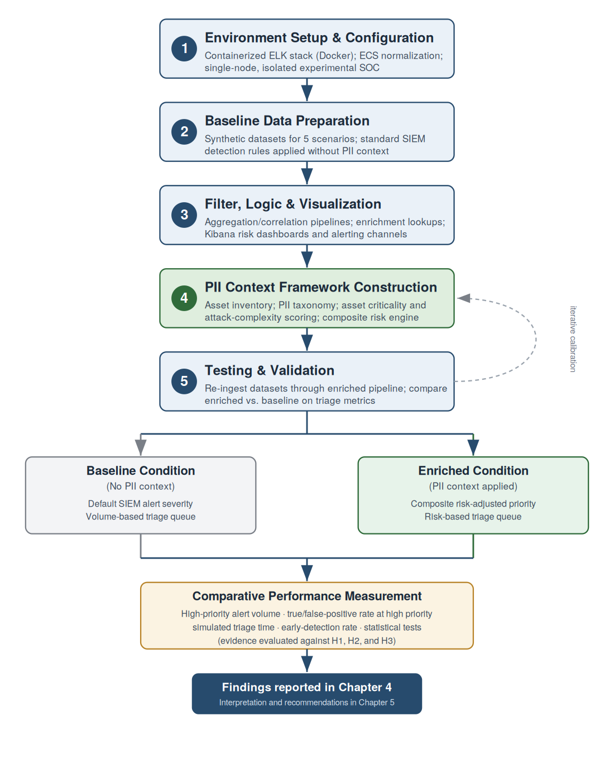
Figure 3.1 Five Stages for Implementing, Testing and Validating PII Framework

Each stage builds directly upon the outputs of the preceding stage, establishing a progression from environment configuration to framework validation. The Framework for Evaluation in Design Science (FEDS) (Venable et al., 2016) guided the evaluation strategy, ensuring that both the absence and presence of PII context can be measured against identical synthetic attack scenarios, enabling direct comparison of analyst triage performance under each condition.
The five numbered stages form the constructive backbone of the study. The flow branches after ECS normalization into the baseline condition (no PII context, executed in Stage 2) and the enriched condition (PII context applied, executed in Stage 5); both conditions feed a single comparative performance-measurement step whose outputs constitute the evidence base for the three hypotheses. The dashed return path from validation to framework construction represents the iterative calibration of scoring weights described in Section 3.7.4. This figure shows that the contribution of the study is not in any single stage but the controlled comparison the pipeline makes possible.
Rather than studying an existing production deployment, this study builds a purpose-built experimental environment that replicates the core components of a modern SOC, which includes log ingestion, normalization, correlation, alerting, and visualization, using open-source tools that are also directly used as enterprise-grade SIEM deployments (Zimmerman, 2014). This approach allows for controlled, reproducible testing that would be impossible in a live security or production environment. At the same time, because the synthetic attack scenarios are derived from documented real-world TTPs drawn from the MITRE ATT&CK framework and mapped to attack patterns observed in the major breaches analyzed in Chapter 2, the research findings speak directly to the challenges faced by operational SOC teams defending financial institutions against PII-targeting threat actors.
The research also addresses three primary hypotheses introduced in Chapter 1. Hypothesis 1 proposes that analysts using a PII context-aware triage framework will identify and prioritize high-risk threats significantly faster than those relying on standard SIEM alerts alone. Hypothesis 2 holds that correlating anomalous behaviors with PII-specific threat context reduces alert noise and improves escalation of critical events. Hypothesis 3 asserts that detection rules mapped to early-stage behavioral indicators of financial threat actors will produce faster and more accurate prioritization responses when augmented by PII context. The five-stage methodology is specifically designed to generate the empirical evidence necessary to evaluate each of these hypotheses.
The remainder of Chapter 3 is organized as follows. Section 3.2 sets out the design science research approach and the comparative evaluation strategy, together with the rationale for an artificial rather than a naturalistic evaluation setting. Section 3.3 restates the three research questions and three hypotheses and specifies the design element and measurement that addresses each. Section 3.4 presents the two-condition experimental design, including the independent and dependent variables and the controls that hold all other factors constant. Section 3.5 presents the graphical model of the methodology and the conceptual model of the PII Context Framework. Section 3.6 describes the synthetic datasets and the five attack scenarios, walking through the attack profiles constructed to represent realistic PII-targeting threat actor campaigns. Section 3.7 documents the techniques and tools, including the containerized platform, Elastic Common Schema normalization, the aggregation and correlation logic, and the design of the PII Context Framework itself. Section 3.8 explains the testing and validation procedures, including the metrics, measurement protocol, and statistical approach used to assess the framework's effectiveness. Section 3.9 addresses ethical considerations and the limitations of this research design, and Section 3.10 summarizes the chapter.

3.2 Research Approach
This research adopts a design science research (DSR) paradigm combined with a quantitative, comparative evaluation strategy. Design science is appropriate because the central contribution of this study is the construction and evaluation of a novel artifact, the PII Context Framework, rather than the observation of a pre-existing phenomenon (Hevner et al., 2004; Peffers et al., 2007). Hevner et al. (2004) frame design science as the iterative construction and assessment of artifacts that address a relevant organizational problem, and Peffers et al. (2007) provide the six-activity DSR process model, problem identification, objective definition, design and development, demonstration, evaluation, and communication, that structures the progression of this praxis from the problem articulated in Chapter 1 to the validated framework presented here. These stages implemented here are shown in Figure 3.2.

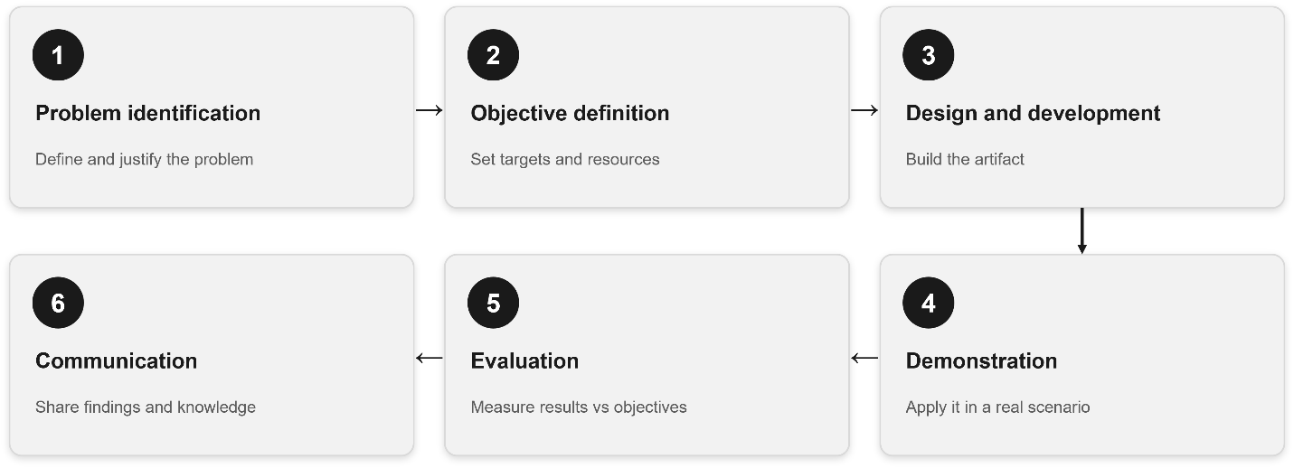
Figure 3.2 Six-Activity DSR Process Model Implemented for this Praxis.

The evaluation strategy is grounded in the Framework for Evaluation in Design Science (FEDS) proposed by Venable et al. (2016), which distinguishes between formative evaluation during artifact construction and summative evaluation of the completed artifact, and which recommends an artificial, controlled evaluation setting when real-world deployment would be premature or ethically constrained. Because production financial-institution telemetry cannot be used without exposing real customer PII, an artificial but rigorously controlled evaluation environment is the methodologically defensible choice. The approach is therefore fundamentally constructive: rather than studying an existing production deployment, the study builds a purpose-built experimental environment that replicates the core components of a modern SOC, log ingestion, normalization, correlation, alerting, and visualization, using open-source tooling that is functionally analogous to enterprise-grade SIEM platforms (Zimmerman, 2014; Detken et al., 2015; Miloslavskaya, 2018).
The study is best characterized as a controlled artifact evaluation that constitutes a within-subjects comparative design. The same synthetic attack data is processed under two conditions, a baseline condition without PII context and an enriched condition with PII context, so that any measured difference in triage performance is attributable to the framework itself rather than to differences in the underlying data. External validity is preserved by deriving every synthetic attack scenario from documented real-world tactics, techniques, and procedures (TTPs) catalogued in the MITRE ATT&CK knowledge base (Strom et al., 2018; MITRE Corporation, 2026) and mapped to the attack patterns observed in the major financial-sector breaches analyzed in Chapter 2. In this way the findings speak directly to the operational challenges of SOC teams defending financial institutions, even though they are generated in a controlled setting.

3.3 Research Questions and Hypotheses
The methodology is designed to investigate the three research questions and three hypotheses introduced in Chapter 1. This section restates them and specifies, for each, the design element and measurement that addresses it. Grounding each question in the gaps identified in Chapter 2 ensures that the methodology investigates the actual problem rather than a proxy for it.

3.3.1 Research Questions
Q1. To what extent do current UEBA and SIEM platforms fail to correlate user behavioral anomalies with the specific sensitivity levels of PII and banking data? This question is investigated through the baseline condition (Stage 2), in which standard detection rules operate without any PII metadata, establishing an empirical reference point for the magnitude of the correlation gap described by Crowley (2024) and Tariq et al. (2025).
Q2. What contextual variables are most critical for an analyst to automate the mapping of "data-at-rest" security insights into real-time "data-in-use" behavioral alerts, thereby providing a more accurate representation of risk? This question is addressed by the design of the PII Context Framework (Stage 4), whose three contextual inputs operationalize the contextual signals that Chapter 2 identified as absent from current triage workflows. The enrichment pipeline (Stages 3 and 4) encodes the framework and applies them to streaming events at ingestion time, directly addressing the integration gap between Data Security Posture Management and the SIEM.
Q3. Does the application of a context-aware risk scoring model significantly reduce the noise of false positives compared to standard anomaly detection rules? This question is answered quantitatively in the validation stage (Stage 5) by comparing false-positive rates at high priority between the baseline and enriched conditions.

3.3.2 Hypotheses
H1. Analysts using a PII context-aware triage framework will identify and prioritize high-risk threats to banking and credit-card PII significantly faster than analysts using standard SIEM/UEBA alerts without integrated data-sensitivity context. H1 is evaluated through the simulated triage-time metric under blinded conditions (Section 3.8).
H2. Correlating anomalous behaviors with specific PII-related threat context reduces the noise of non-critical behavioral alerts and improves the escalation of critical anomalies relative to less significant ones. H2 is evaluated through the high-priority alert volume, the true-positive rate at high priority, and the alert-distribution-shift metric.
H3. Organizations that implement detection rules mapped to the early-stage behavioral indicators of financial threat actors will prioritize and respond to such threats faster when a PII context-aware framework is applied. H3 is evaluated through the early-detection-rate metric, which tests whether high-priority risk scores are assigned to early-stage indicators (for example, lateral movement) before the bulk-exfiltration phase generates more obvious signals (Sloan, 2025; Strom et al., 2018).

3.4 Experimental Design
The experimental design is a single-environment, two-condition comparative evaluation executed over five synthetic attack scenarios. The independent variable is the presence or absence of PII context enrichment. The dependent variables are the triage-performance metrics defined in Section 3.8: high-priority alert volume, true-positive and false-positive rates at high priority, simulated triage time, and early-detection rate. All other factors, the underlying event data, the detection rules, the analyst evaluators, and the visualization interface, are held constant across conditions so that observed differences can be attributed to the framework.
As can be seen in Figure 3.3, holding the data constant across conditions is the core control of the design. Each synthetic dataset is normalized once to the Elastic Common Schema (ECS) and then processed through two parallel pipelines that produce two parallel sets of Elasticsearch indices. The only difference between the indices is the presence of the populated pii.context namespace fields in the enriched condition and their absence in the baseline condition. This dual-index architecture enables direct, field-level comparison against identical underlying events and eliminates dataset variability as a confounding factor (Sommer & Paxson, 2010; Ring et al., 2019).

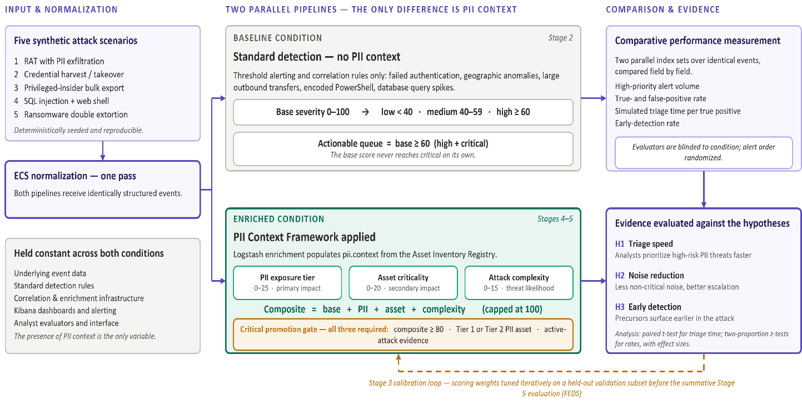
Figure 3.3 End-to-end Experimental Design across Two Parallel Pipelines

The design proceeds through five sequential stages, each building on the outputs of the prior stage, as depicted in Figure 3.1. Stage 1 establishes an experimental environment. Stage 2 prepares the baseline data and applies standard detection without PII context, producing the comparison reference point. Stage 3 develops the filter, correlation, and visualization infrastructure shared by both conditions. Stage 4 constructs the PII Context Framework and its risk-scoring and promotion engine. Stage 5 re-executes the enriched pipeline and measures performance against the Stage 2 baseline. Consistent with the formative evaluation guidance of FEDS (Venable et al., 2016), the scoring model is calibrated iteratively against a small held-out validation subset before the summative Stage 5 evaluation is conducted, a feedback loop indicated in Figure 3.3.
To manage scope and to validate the pipeline end-to-end before the full five-scenario evaluation, the Remote Access Trojan (RAT) scenario described in Section 3.6 is implemented first as a proof of concept. This staged implementation is consistent with the research scope defined in Chapter 1, which framed the initial work as building and validating the framework against a small set of representative scenarios before broader testing. The RAT scenario exercises every component of the framework, ingestion, normalization, correlation, enrichment, scoring, and alerting, and therefore confirms that the methodology is sound before it is generalized across the remaining four scenarios.

3.5 The Graphical Model and Conceptual Framework
Outside of Figure 3.3, the other model that anchors this research is presented in Figure 3.4, which is the conceptual model of the PII Context Framework itself, specifying how the base anomaly risk score is preserved and enriched with contextual inputs that can promote an alert to critical priority when an attack targeting PII is confirmed.

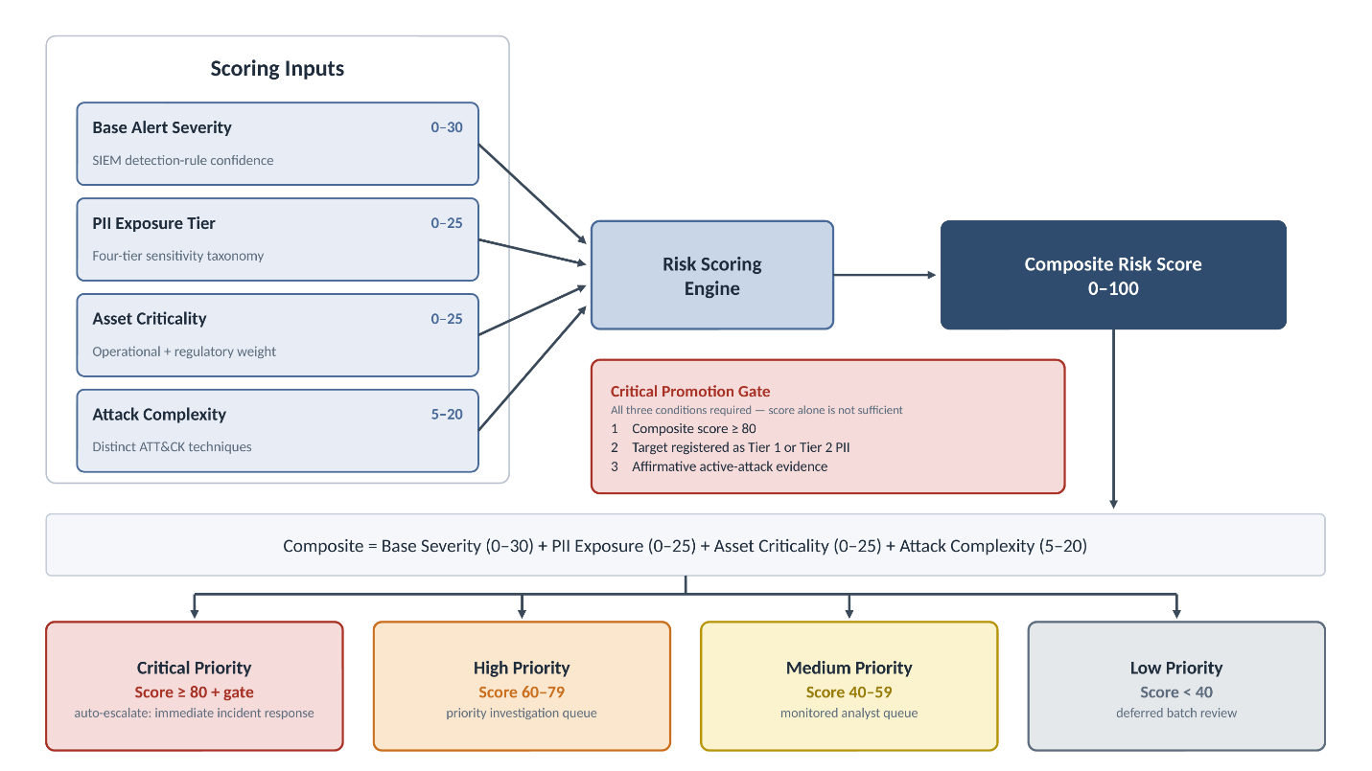
Figure 3.4 Conceptual model of the PII Context Framework

Figure 3.4 specifies the framework's internal logic. The base alert severity is scored on a 0–100 scale by the standard detection and anomaly rules, independent of any PII context, and is mapped to one of three base priority tiers by threshold: scores of 60 and above are classified as high and routed to the priority investigation queue; scores between 40 and 59 enter a monitored medium-priority queue; and scores below 40 are classified as low and deferred for batch review. The base score never reaches critical on its own. The PII Context Framework then operates as a bounded, weighted promotion layer implemented across the Logstash enrichment layer and Elasticsearch aggregation queries. The framework restricts promotion to critical priority through two separate mechanisms: a weighting model that determines how high an alert's composite score can rise, and a promotion gate that determines whether the alert is eligible for critical priority at all. Each mechanism serves a different purpose. The weighting is bounded so that an alert cannot reach the critical threshold without a data-sensitivity contribution. The base severity produced by the standard detection and anomaly rules is retained on its native 0–100 scale for base tier assignment and normalized to a maximum contribution of 30 points to the composite; the PII exposure tier of the targeted asset contributes up to 25 points (primary impact), its asset criticality up to 25 points (secondary impact), and the attack complexity of the correlated behavior between 5 and 20 points (threat likelihood). Each is converted to an individually stored, bounded contribution and summed (composite = base + PII + asset + complexity). The four maximum contributions total exactly 100, so no cap is required. Based on this, an alert against an asset carrying no PII exposure has a maximum attainable composite of 75, which falls inside the high band and cannot reach the critical threshold of 80. Now, impact dominates likelihood in the model as the most sophisticated attack against the most business-critical asset is limited to high priority when the asset holds no sensitive data, consistent with the risk formulation Risk = f(Impact, Likelihood) (National Institute of Standards and Technology [NIST], 2012). The reverse is also true. PII exposure alone is not sufficient, since an asset registered as holding Tier 1 PII with no detection signal and no correlated technique reaches a composite of only 25. The gate addresses a limitation of the weighting. Because asset criticality is scored independently of PII content, operational importance alone can drive a composite upward without any regulated data being at risk, and a Tier 3 asset combining high base severity with a complex technique chain can reach the threshold on points alone. The gate therefore imposes two conditions that cannot be satisfied by score alone: the target must be registered in the Asset Inventory Registry as holding Tier 1 or Tier 2 PII, and there must be direct evidence of an active attack, either observed PII exposure in the event or a correlated MITRE ATT&CK technique chain. The composite score establishes that an event is serious; the gate establishes that it is directed at regulated PII. Both are required to justify immediate incident response, which is why ambient traffic on a PII-holding asset does not qualify, and why a sophisticated intrusion against non-sensitive data is escalated to high but never promoted to critical. This model embeds data-sensitivity context directly into alert prioritization, the integration that Chapter 2 identified as the missing link between data governance and security operations (Pendleton et al., 2016; NIST, 2012).

3.6 Datasets
This research uses synthetic datasets generated specifically for the study. Synthetic data is necessary for both ethical and methodological reasons: it eliminates any exposure of real customer PII, and it permits deterministic, reproducible generation so that identical datasets can be processed under both experimental conditions (Sommer & Paxson, 2010; Sharafaldin et al., 2018). Each dataset is generated with custom Python log-generation scripts seeded deterministically, so that the same seed produces an identical dataset across test runs and dataset variability is removed as a confounding variable (Ring et al., 2019).
Each dataset contains both malicious and benign events. Benign events simulate normal business activity, routine authentication, scheduled database backups, authorized file access, and ordinary web traffic, and create the alert-noise conditions characteristic of real SOC environments. The ratio of malicious to benign events is set up to approximate the signal-to-noise ratios documented in SOC research, in which true-positive alerts typically represent only a small fraction of total daily alert volume, reproducing the alert-fatigue conditions described in Chapter 2 (Crowley, 2024; Tariq et al., 2025). Every dataset is normalized once to ECS before ingestion so that both conditions operate on identically structured events (Brahmam, 2023).
Five scenarios were designed, each targeting a distinct PII category, employing a different initial-access vector, and producing a unique behavioral signature, so that the framework must demonstrate breadth of coverage rather than optimization for a single attack pattern (Strom et al., 2018; MITRE Corporation, 2026). To make sure the datasets and attack scenarios were valid situations for a SOC team, they were modeled after the attacks listed in section 2.4. Each scenario is specified in three layers: the attacker objective (the PII types targeted), the technique chain (mapped to MITRE ATT&CK tactics and techniques), and the log signature (the event fields and sequences generated in the experimental environment).

3.6.1 Primary Scenario: Remote Access Trojan with PII Exfiltration
The RAT scenario is the initial implemented scenario and the proof of concept for the full methodology. RAT campaigns are a well-documented and severe threat to financial institutions because they grant persistent, interactive control of a compromised host from which an operator can locate and exfiltrate sensitive data over an extended period (El-Metwaly et al., 2024). The scenario, as detailed in Figure 3.5, simulates a spear-phishing delivery of a RAT to a financial-institution employee with access to customer Social Security numbers and bank-account records. The technique chain begins with initial access via a malicious email attachment (T1566.001, Spearphishing Attachment), establishes persistence through a Windows registry Run key modification (T1547.001, Registry Run Keys), proceeds through PowerShell-based file and directory discovery targeting directories known to contain SSN and account data (T1083 and T1005), and culminates in staged exfiltration over a command-and-control channel (T1074.001 and T1041) (Applebaum et al., 2016; MITRE Corporation, 2026).

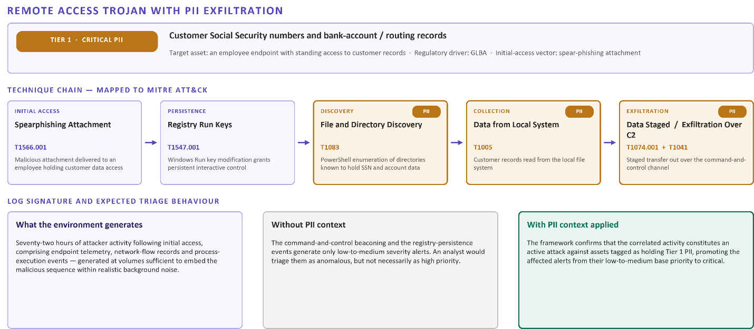
Figure 3.5 Scenario 1: Remote Access Trojan (RAT) targeting PII for Exfiltration

The synthetic log data for the RAT scenario simulates 72 hours of attacker activity following initial access and includes endpoint telemetry, network-flow records, and process-execution events at volumes sufficient to embed the malicious sequence within realistic noise. Without PII context, the command-and-control beaconing and registry-persistence events are expected to generate only low-to-medium-severity alerts that would be triaged as anomalous but not necessarily high priority (Crowley, 2024). With PII context applied, the framework is expected to confirm that the correlated activity constitutes an active attack against assets tagged as containing Tier 1 PII, promoting the affected alerts from their low-to-medium base priority to critical (Hubbard & Seiersen, 2023). Because the RAT scenario exercises every stage of the pipeline, its successful execution validates the methodology before it extends to the remaining four scenarios.

3.6.2 Remaining Scenarios
As seen in Figure 3.6, Scenario 2 simulates a credential-harvesting campaign and online-banking account takeover, chaining phishing delivery of a credential-harvesting page (T1566.002), anomalous authentication from new geographic locations (T1078), and session-token theft (T1539 and T1185). It tests whether the framework correctly elevates authentication anomalies when they are associated with the authentication gateway for accounts containing high-sensitivity banking PII (Pendleton et al., 2016; NIST, 2012).

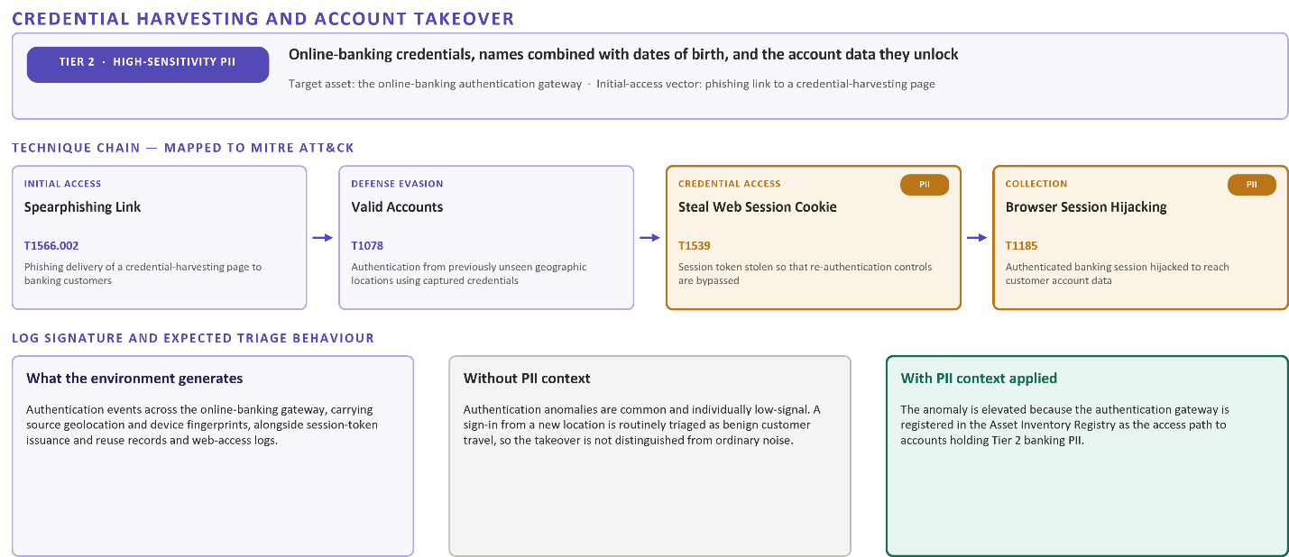
Figure 3.6 Scenario 2: Credential Harvesting and Online Banking Account Takeover

Scenario 3 simulates a privileged-insider threat in which a database administrator conducts bulk exports of full customer records comprising Social Security numbers, account numbers, and credit histories, all classified as Tier 1 PII. The scenario is illustrated in Figure 3.7. It chains legitimate-credential abuse (T1078.002), unauthorized bulk data collection (T1530, adapted to an on-premises database context), and exfiltration through an external cloud-synchronization service (T1048 and T1567). This scenario is the most challenging for standard detection because the actor uses legitimate credentials within the scope of an administrative role. Therefore, the framework is expected to differentiate authorized bulk access from unauthorized bulk export by correlating event volume and frequency against the PII sensitivity tier of the targeted tables (Greitzer & Ferryman, 2013; McCallister et al., 2010).

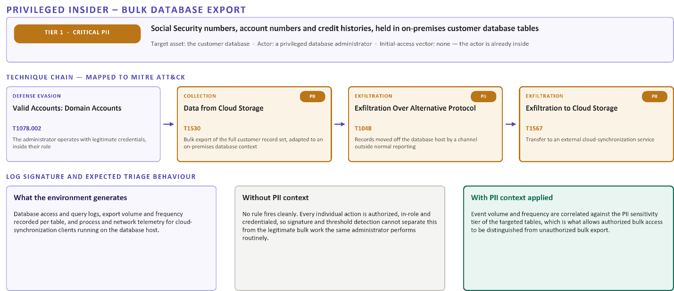
Figure 3.7 Scenario 3: Insider Threat from Privileged User Illegally Exporting Customer Database

Scenario 4 simulates an external attacker exploiting a SQL injection vulnerability (T1190) in a web-facing financial application, deploying a web shell for persistence (T1505), and then staging and executing the exfiltration of credit-card records, specifically full payment-card account numbers classified as Tier 1 PII (T1074 and T1041). It tests whether the framework elevates application-layer indicators that appear in isolation as routine error logs when those indicators are associated with assets hosting cardholder data subject to PCI DSS requirements (Payment Card Industry Security Standards Council [PCI SSC], 2022). Figure 3.8 illustrates the technique flow.

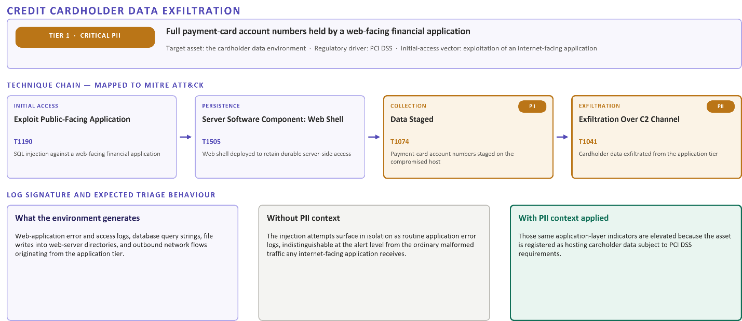
Figure 3.8 Scenario 4: SQL Injection Attack Leading to Theft of Credit Card Data

Scenario 5 simulates a Ransomware-as-a-Service double-extortion operation with pre-encryption PII exfiltration, the most complex and multi-stage campaign of the five. It spans initial access via an exposed remote service (T1133), lateral tool transfer (T1570), bulk staging of HR files and customer PII, that includes government-issued identification documents, spanning Tier 1 and Tier 2 classifications, while using tooling such as Rclone and MEGAsync (T1560 and T1537), pre-encryption exfiltration (T1041 and T1567), and finally ransomware deployment (T1486) (Applebaum et al., 2016; MITRE Corporation, 2026). Its extended timeline approximates real-world ransomware dwell time and tests whether the framework can reveal early-stage behavioral indicators as elevated-priority events before the bulk-exfiltration phase begins (Sloan, 2025). Dataset construction for this scenario draws on established methodologies for realistic intrusion simulation (Sharafaldin et al., 2018). Figure 3.9 illustrates the full campaign.

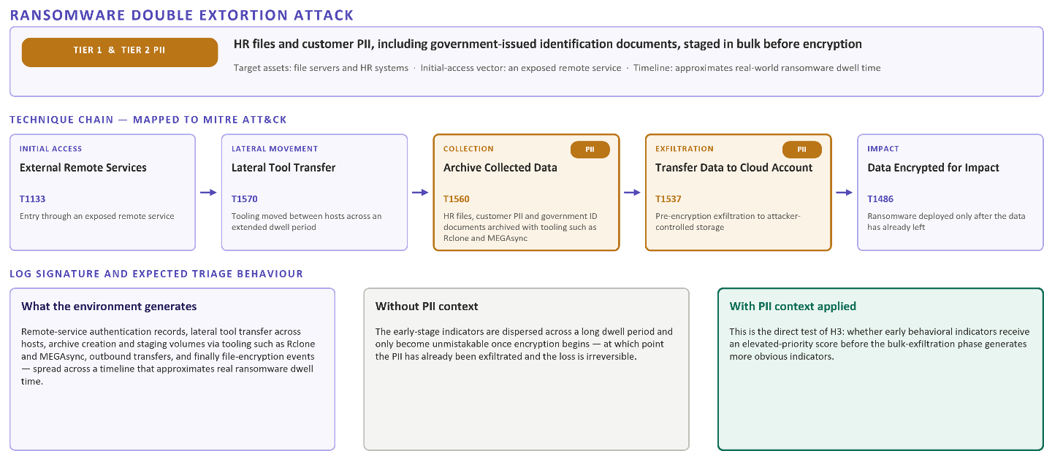
Figure 3.9 Scenario 5: Ransomware Double Extortion Attack with Data Exfiltration

3.7 Techniques and Tools
The experimental environment is constructed from open-source components that are architecturally analogous to enterprise SIEM platforms while remaining fully transparent and reproducible. This section documents the platform, the data-normalization standard, and the PII Context Framework components that constitute the study's technical apparatus.

3.7.1 Platform and Containerization
The environment is built on the Elasticsearch, Logstash, and Kibana (ELK) stack deployed in Docker containers on an Ubuntu Linux host (Merkel, 2014). ELK was selected for three reasons. First, it is architecturally analogous to enterprise SIEM platforms such as Splunk, Microsoft Sentinel, and IBM QRadar in supporting centralized ingestion, schema-based normalization, correlation-rule development, and dashboard visualization (Detken et al., 2015; Miloslavskaya, 2018). Second, its open-source nature permits full documentation and sharing of every configuration file, pipeline definition, and detection rule without licensing restrictions. Third, its native support for the Elastic Common Schema provides a standardized data model consistent with real-world SIEM ingestion (Elastic N.V., 2026a). Containerization with Docker provides environmental isolation, reproducibility, and portability; each component runs in its own container with dedicated resources, and a single-node configuration is used throughout, reflecting the experimental scope and avoiding distributed-cluster complexity irrelevant to the research questions (Pahl & Jamshidi, 2016).
Within the stack, Elasticsearch functions as the indexed data store and query engine for normalized events, enriched alert records, and computed risk scores (Elastic N.V., 2026a). Logstash serves as the ingestion and transformation pipeline, parsing, normalizing, and enriching events before indexing. Its translate filter plugin provides the dictionary-based enrichment that is central to the PII context step in Stage 4 (Elastic N.V., 2026b; Turnbull, 2020). Kibana provides the visualization, dashboarding, and alerting interface, including the risk-heatmap dashboards and the threshold-based alerting that replicate the SIEM alerting workflow analysts experience in production (Elastic N.V., 2026c). Figure 3.10 illustrates the environment used that closely simulates an actual enterprise SOC environment that leverages the ELK stack.
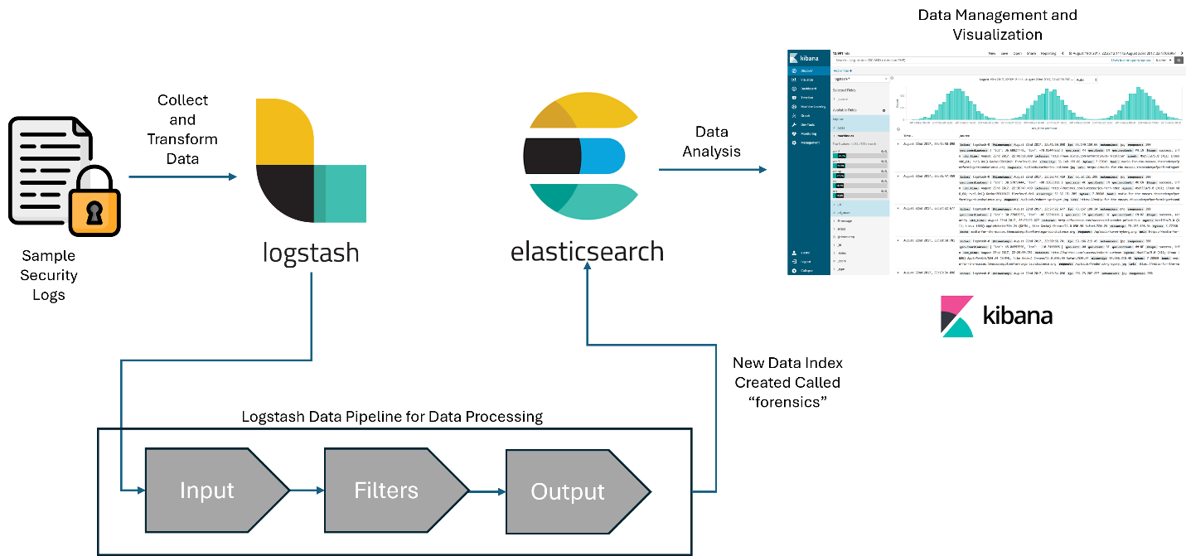
Figure 3.10 The SIEM Environment that Simulates a Typical SOC Environment

3.7.2 Data Normalization: Elastic Common Schema
The Elastic Common Schema (ECS) is adopted as the normalization standard because it mirrors the normalization requirements of enterprise SIEM deployments, most of which implement equivalent field standardization (for example, Microsoft Sentinel's ASIM and Splunk's CIM) to enable cross-source correlation (Elastic N.V., 2026a; Brahmam, 2023). Normalization is performed at the Logstash layer, mapping each event type, endpoint telemetry, network flow, authentication, database access, and file-system activity, to its corresponding ECS fields. To support PII enrichment, the ECS implementation is extended with a custom pii.context namespace that does not conflict with existing ECS definitions. It carries fields for asset criticality, PII exposure tier, data classification, the base risk score and priority tier, and the promotion status, populated by the Stage 4 enrichment pipeline (Elastic N.V., 2026b).

3.7.3 Aggregation, Correlation, and Visualization Logic
Effective PII-aware triage requires that individual events be aggregated into behavioral sessions before risk scoring is applied, because a single event carries limited signal whereas a correlated sequence on a sensitive asset constitutes a materially different risk profile (Pendleton et al., 2016; Hubbard & Seiersen, 2023). The Logstash pipeline computes and attaches synthetic correlation identifiers that group related events across time windows, enabling Elasticsearch aggregation queries without a stateful event-processing architecture (Elastic N.V., 2026a). Enrichment lookups are implemented with the translate filter plugin and in-memory dictionaries. From there a threat-intelligence dictionary maps malicious address ranges to classification labels, and an asset-sensitivity dictionary maps host identifiers to PII context metadata (Turnbull, 2020). A Kibana risk-heatmap dashboard provides the monitoring interface for both conditions, presenting risk concentration across assets over time, alert-volume histograms, PII-exposure distribution, and a triage queue sortable by promoted priority and base risk score (Elastic N.V., 2026c; Jangampet et al., 2024). The components developed in this stage are highlighted in Table 3.1.

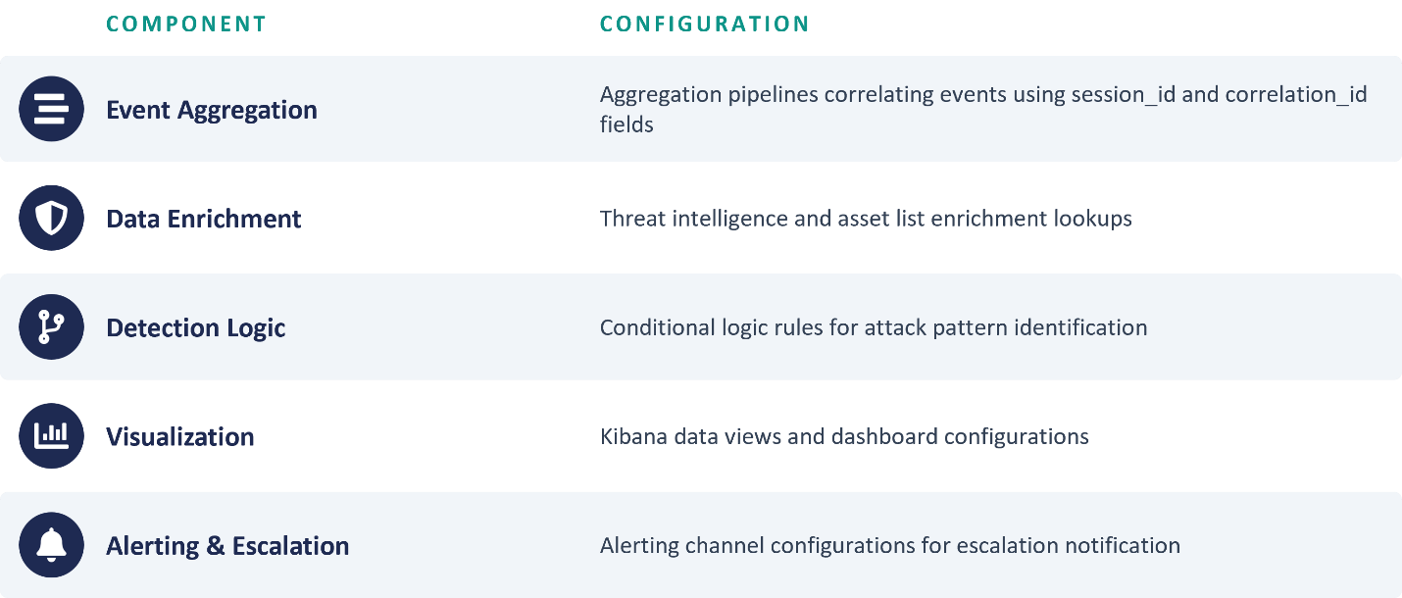
Table 3.1 Detection Pipeline Configuration for Correlation, Enrichment and Alerting

3.7.4 The PII Context Framework
The PII Context Framework is the core artifact of the study. It comprises four interconnected components: (a) an Asset Inventory Registry, which maps each asset to its role, the PII categories it stores, its sensitivity tier, applicable regulatory requirements, and a base criticality score; (b) a PII Classification Taxonomy; (c) a Risk Scoring Engine; and (d) an Enrichment Pipeline implemented within Logstash (Hubbard & Seiersen, 2023; Elastic N.V., 2026b). The taxonomy and the scoring inputs are summarized below and depicted in Table 3.2.
The PII Classification Taxonomy defines four sensitivity tiers, synthesized from regulatory requirements, breach case-study analysis, and existing classification guidance (McCallister et al., 2010). Tier 1 (Critical PII) covers data types that individually enable identity fraud or financial account takeover, Social Security numbers, full card numbers, and bank-account and routing combinations, subject to the highest regulatory protection under GLBA (U.S. Federal Trade Commission, n.d.) and PCI DSS (PCI SSC, 2022) and associated with the highest per-record breach cost (IBM Security & Ponemon Institute, 2025). Tier 2 (High-Sensitivity PII) covers data that amplifies attacker targeting, such as names combined with dates of birth and account credentials (Henry, 2025). Tier 3 (Moderate-Sensitivity PII) covers data commonly used in social engineering, such as email addresses and phone numbers. Tier 4 (Low-Sensitivity PII) covers publicly available or minimally sensitive data. Each tier feeds the promotion criteria, with Tier 1 and Tier 2 associations serving as the primary condition for promoting an alert to critical, and assets bearing no PII association never qualifying for promotion.
Asset criticality scoring is a secondary promotion criterion reflecting the operational importance of the targeted asset beyond its PII content, assigned from criteria including the asset's role in core business processes, the number of dependent downstream systems, its regulatory classification, its exposure surface, and its vulnerability status (Hubbard & Seiersen, 2023; NIST, 2012). Attack complexity scoring captures behavioral sophistication and is assigned dynamically from the number of distinct MITRE ATT&CK techniques observed across correlated events, with higher scores for multi-stage campaigns exhibiting lateral movement, extended dwell time, or advanced evasion (Strom et al., 2018; Applebaum et al., 2016; Sloan, 2025).
The base alert severity is retained as a 0–100 score produced by the standard detection and anomaly rules and mapped to low (below 40), medium (40–59), or high (60 and above) priority; it never reaches critical on its own. The Risk Scoring Engine then applies the PII context as a bounded, weighted promotion layer rather than a replacement for the base score: the PII exposure tier, asset criticality, and attack complexity are each converted to an individually stored, capped contribution (up to 25, 25, and 20 points respectively) and added to a normalized base severity contribution of up to 30 points to produce a composite risk score whose four maximum contributions total exactly 100, so that every escalation carries a decomposed, auditable rationale that sums exactly to the composite. An alert is promoted to critical priority when its composite score reaches the promotion threshold (80 or above) and it reflects a confirmed, targeted threat to regulated PII, defined as an asset registered as holding Tier 1 or Tier 2 PII together with real evidence of an active attack, either observed PII exposure in the event or at least one correlated MITRE ATT&CK technique; asset criticality contributes additional weight for borderline cases (Pendleton et al., 2016; NIST, 2012). Because an asset carrying no PII exposure has a maximum attainable composite of 75, which falls inside the high-band, attack sophistication alone cannot promote an alert directed at non-sensitive data. Because asset criticality is scored independently of PII content, however, a high composite score is not by itself evidence that regulated data is at risk, which is why the Tier 1 or Tier 2 registration requirement in the promotion gate remains necessary in addition to the score threshold. The contribution weights, base-tier thresholds, and promotion criteria are calibrated iteratively during Stage 4 using a held-out validation subset, consistent with the formative-evaluation guidance of FEDS, before the summative Stage 5 evaluation (Venable et al., 2016).

Element | Definition / example data types | Score contribution | Role in critical promotion
Tier 1 — Critical PII | Social Security numbers; full payment-card numbers; bank-account and routing combinations | PII exposure: 25 (primary impact) | Qualifying PII target
Tier 2 — High-sensitivity PII | Names combined with dates of birth; account credentials | PII exposure: 18 | Qualifying PII target
Tier 3 — Moderate-sensitivity PII | Email addresses; phone numbers | PII exposure: 8 | Not qualifying
Tier 4 — Low-sensitivity PII | Publicly available or minimally sensitive data | PII exposure: 0 | Not qualifying; assets with no PII association never promote
Base alert severity | Output of standard detection and anomaly rules | 0–30 normalized contribution; native 0–100 scale sets the base tier (low < 40, medium 40–59, high ≥ 60) | Never reaches critical alone
Asset criticality | Registry-assigned operational importance of the targeted asset | 0–25 (secondary impact) | Additional weight for borderline cases
Attack complexity | Count and sophistication of correlated MITRE ATT&CK techniques | 5–20 (threat likelihood) | Cannot promote alerts on non-sensitive data
Critical promotion gate | Composite ≥ 80 with a Tier 1/2 PII asset and active-attack evidence | — | Required for critical priority
Table 3.2 PII Classification Taxonomy and Risk-Scoring Inputs

Table 3.3 illustrates the interaction of the two mechanisms at the boundaries of the scoring rules. These cases follow directly from the scoring weights and the promotion gate rather than from experimental results; they are included to show how the scoring rules behave at their boundary conditions.

Case | Composite calculation | Composite | Gate satisfied | Resulting priority
No PII exposure; all other inputs at maximum | 30 + 0 + 25 + 20 | 75 | No — no Tier 1 or Tier 2 registration | High
Tier 3 asset; all other inputs at maximum | 30 + 8 + 25 + 20 | 83 | No — not Tier 1 or Tier 2 | High
Tier 1 asset; confirmed active attack | 30 + 25 + 25 + 20 | 100 | Yes — all three conditions met | Critical
Tier 1 asset; no detection signal or correlated technique | 0 + 25 + 0 + 5 | 30 | No — no active-attack evidence | Low
Table 3.3 Illustrative Boundary Cases of the Composite Scoring and Promotion Rules

3.8 Testing Procedures
Stage 5 executes the full enriched pipeline against each scenario and measures performance against the baseline established in Stage 2. The procedure is designed to produce quantitative evidence directly relevant to the three hypotheses while maintaining methodological rigor appropriate to doctoral research (Hevner et al., 2004; Venable et al., 2016).

3.8.1 Baseline Establishment and Enriched Execution
In Stage 2, standard detection rules are applied to each dataset using Elasticsearch threshold alerting and the Kibana rules engine, replicating a mature but standard SOC detection capability, signature-based correlation, threshold rules, and basic behavioral baselines, with no asset-specific PII weighting (Detken et al., 2015; Zimmerman, 2014). The standard detection rules applied in the baseline condition are documented in Table 3.4.

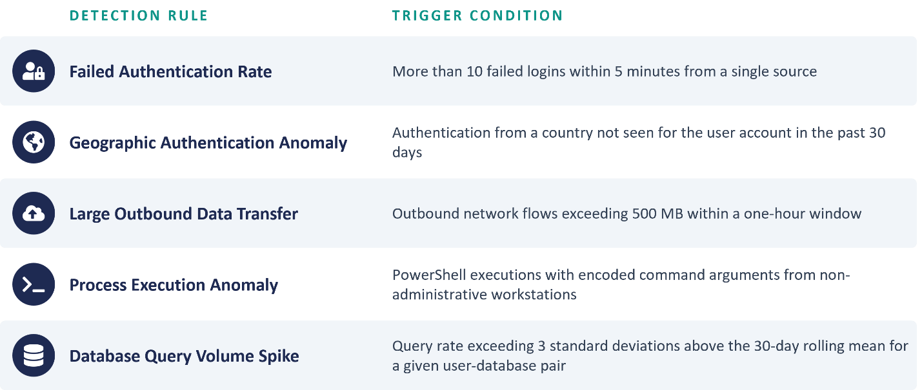
Table 3.4 Security Detection Rules and Triggers

The representative rule set includes failed-authentication thresholds, geographic authentication anomalies, large-outbound-transfer alerts, encoded-PowerShell execution anomalies, and database-query-volume spikes, all consistent with baseline detection capabilities documented in the SOC literature (Nagaraj, 2023; Jangampet et al., 2024). For each scenario, the baseline procedure records total alert volume, true-positive rate, and simulated triage time, the comparison reference point against which the enriched results are evaluated (Sundaramurthy et al., 2014).
In Stage 5, the complete PII Context Framework configuration, the Asset Inventory Registry, the taxonomy tier assignments, and the attack-complexity scoring logic, is loaded into Logstash, and each dataset is re-ingested through the enriched pipeline (Elastic N.V., 2026b). This produces a parallel set of Elasticsearch indices containing the original ECS fields plus the populated pii.context fields, enabling direct field-level comparison against the identical underlying events (Elastic N.V., 2026a). Aggregation queries then classify each alert into low (< 40), medium (40–59), or high (≥ 60) priority from its base score, and apply the promotion criteria to elevate alerts reflecting a confirmed PII attack to critical priority, replicating the operational workflow in which low-priority alerts are deferred for batch review (Jangampet et al., 2024; Crowley, 2024). For metric computation, the analyst's actionable high-priority queue is condition-specific: in the baseline condition it comprises the high and critical tiers jointly (base score ≥ 60), the best prioritization a context-blind SOC can make, whereas in the enriched condition it is the promoted critical tier, the confirmed-PII-attack queue the framework surfaces for immediate response—preserving comparability with the binary escalation decision embedded in the performance metrics.

3.8.2 Primary Performance Metrics
Five primary metrics measure the framework's impact on the three hypothesized dimensions of triage speed (H1), alert-noise reduction (H2), and early detection within the attack chain (H3) (Sundaramurthy et al., 2014; Greitzer & Ferryman, 2013): (1) high-priority alert volume, the number of alerts classified high-priority in each condition; (2) true-positive rate at high priority, the proportion of high-priority alerts that correctly correspond to malicious activity; (3) simulated triage time per true-positive detection, the average analyst time to correctly identify a true positive as requiring escalation; (4) false-positive rate at high priority; and (5) early-detection rate, the proportion of scenarios in which an early-stage indicator, for example, a lateral-movement event early in the Scenario 5 timeline, receives a high-priority score before the bulk-exfiltration phase generates more obvious indicators (Strom et al., 2018; Sloan, 2025).Triage-time measurements use a standardized protocol administered to trained analyst evaluators who assess alerts from both conditions in randomized, blinded order, without being told which condition each alert is drawn from; triage time is recorded from presentation of the alert to the documented triage decision.

3.8.3 Secondary Validation Metrics
Secondary metrics provide additional evidence of the framework's operational characteristics. The alert-distribution-shift metric measures the change in the proportion of alerts across priority tiers between conditions, quantifying how far PII enrichment concentrates the high-priority tier around true positives (Pendleton et al., 2016). The PII-exposure-coverage rate confirms that the Asset Inventory Registry covers the assets implicated in the test scenarios. The promotion-precision metric evaluates whether alerts promoted to critical are significantly more likely to be true positives than alerts remaining at their base priority, confirming that the promotion logic isolates confirmed attacks targeting PII rather than uniformly escalating alerts. The early detection rate, which bears directly on H3, is treated as a primary rather than a secondary metric and is defined in Section 3.8.2.

3.8.4 Statistical Analysis Approach
Quantitative analysis employs descriptive statistics for all metrics and, where sample sizes permit, inferential tests for the primary metrics and for promotion precision (Agresti & Franklin, 2018). A paired t-test compares simulated triage times between conditions using a within-subjects design that controls for evaluator-level variability, and Cohen's d is reported as the effect size to assess practical as well as statistical significance (Cohen, 1988). The difference in true-positive rate at high priority is assessed with a two-proportion z-test, and the promotion-precision analysis uses a two-proportion z-test comparing the true-positive rate among alerts promoted to critical with that among alerts remaining at their base priority (Agresti & Franklin, 2018). Because the early-detection rate is computed over only five scenarios, it is reported descriptively, with the detection point for each scenario tabulated against the attack timeline rather than tested inferentially.
So, it is recognized that the small number of distinct scenarios and the controlled nature of the synthetic environment limit the generalizability of statistical inferences (Peffers et al., 2007; Venable et al., 2016). Accordingly, the primary contribution of the analysis is not population-level generalization but proof-of-concept evidence that the framework produces measurable, directionally consistent improvements in SOC triage effectiveness across a diverse set of PII-targeting scenarios.

3.9 Ethical Considerations and Research Limitations
This research is conducted exclusively with synthetic data generated for the study. No real customer PII, production security logs, or actual financial-institution data is used at any stage, and the synthetic scenarios do not reference specific ongoing investigations, real threat actors, or breach incidents beyond the published case studies analyzed in Chapter 2. This design eliminates the ethical concerns associated with exposing or misusing sensitive personal data (Hevner et al., 2004). The attack techniques are derived from publicly available sources, the MITRE ATT&CK knowledge base (Strom et al., 2018; MITRE Corporation, 2026), peer-reviewed literature, and documented breach post-mortems, and are presented at a level of abstraction appropriate to academic contribution; they do not constitute operational attack instructions. However, they do an accurate job of providing real-world attack accuracy for a SOC that provides confidence in testing and potential validation of the hypotheses.

3.9.1 Research Limitations
Several limitations must be acknowledged. First, synthetic data, while necessary for ethical and practical reasons, cannot fully replicate the noise characteristics, temporal patterns, and operational context of production log streams (Sommer & Paxson, 2010; Ring et al., 2019); future work should validate the framework against de-identified production data from consenting institutions. Second, the single-node ELK deployment does not replicate the scale or distributed architecture of enterprise SIEM platforms, so the computational efficiency of the scoring engine at enterprise volume remains to be validated (Pahl & Jamshidi, 2016). Third, the five scenarios, though representative of major PII-targeting categories, cannot encompass the full diversity of adversary techniques, and the framework's performance against novel techniques excluded by the ATT&CK-derived design cannot be assessed here (Strom et al., 2018). Fourth, the simulated triage-time measurements rely on a limited pool of analyst evaluators and may not generalize across all experience levels and organizational contexts (Sundaramurthy et al., 2014). Fifth, the scoring and promotion model is calibrated for this specific environment and scenario set; organizations deploying it will need to recalibrate the base-tier thresholds and promotion criteria to their own asset landscape, regulatory requirements, and risk tolerance, with guidance provided in Chapter 5 (Hubbard & Seiersen, 2023; Pendleton et al., 2016).

3.10 Chapter Summary
This chapter presented the methodology for designing, implementing, and validating the PII Context Framework. The research adopts a design science paradigm, following the six-activity process depicted in Figure 3.2, with a controlled, comparative evaluation strategy executed across the five sequential stages of Figure 3.1 (Hevner et al., 2004; Peffers et al., 2007; Venable et al., 2016), investigating three research questions and three hypotheses by processing identical synthetic attack data under a baseline condition without PII context and an enriched condition with it. The experimental design holds the data, detection rules, evaluators, and interface constant across conditions so that measured differences are attributable to the framework alone. Two graphical models anchor the study: the end-to-end methodology pipeline (Figure 3.3) and the base-score and context-based promotion conceptual model (Figure 3.4).
The datasets comprise five synthetic scenarios spanning Remote Access Trojan, credential harvesting, insider threat, SQL injection, and ransomware double-extortion campaigns, with the RAT scenario implemented first as the proof of concept that validates the full pipeline. The techniques and tools, a containerized ELK stack normalized to ECS, Logstash enrichment, Kibana dashboards and alerting (Figure 3.10; Table 3.1), and the four-component PII Context Framework (Table 3.2), operationalize the integration of data sensitivity into the alert lifecycle that Chapter 2 identified as the missing link between data governance and security operations (McCallister et al., 2010; Pendleton et al., 2016). The testing procedures, anchored by four primary metrics and supported by secondary statistical analyses (Cohen, 1988; Agresti & Franklin, 2018), apply the baseline rule set of Table 3.4 and are designed to generate evidence directly relevant to triage-speed improvement, alert-noise reduction, and early-detection accuracy. The results of this validation are reported and interpreted in Chapter 4, and Chapter 5 synthesizes them into implementation recommendations and directions for future research (Venable et al., 2016).

References
Agresti, A., & Franklin, C. (2018). Statistics: The art and science of learning from data (4th ed.). Pearson. https://wrlc-gwu.primo.exlibrisgroup.com/permalink/01WRLC_GWA/1pqr5/alma9911571454304101
Akinsola, F., Ogwueleka, F., & Mbanaso, U. (2025). A comprehensive survey of insider threat landscape and detection indicators. Kwaghe International Journal of Engineering and Information Technology. https://www.researchgate.net/publication/396836137_A_Comprehensive_Survey_of_Insider_Threat_Landscape_and_Detection_Indicators
Akula, V. (2024). SIEM: The heartbeat of a modern SOC. CloudifyOps. Medium. https://medium.com/@CloudifyOps/siem-the-heartbeat-of-a-modern-soc-7ad73131bca8
AmpcusCyber. (2026). What is SIEM? Centralized visibility for modern threats. https://www.ampcuscyber.com/knowledge-hub/what-is-siem-centralized-visibility-for-modern-threats/
Anderson, R., Barton, C., Böhme, R., Clayton, R., van Eeten, M. J. G., Levi, M., Moore, T., & Savage, S. (2013). Measuring the cost of cybercrime. In R. Böhme (Ed.), The economics of information security and privacy (pp. 265–300). Springer. https://link.springer.com/chapter/10.1007/978-3-642-39498-0_12
Applebaum, A., Miller, D., Strom, B., Korban, C., & Wolf, R. (2016). Intelligent, automated red team emulation. In Proceedings of the 32nd Annual Conference on Computer Security Applications (pp. 363–373). Association for Computing Machinery. https://doi.org/10.1145/2991079.2991111
Ben-Ari, D. (2025). TransUnion data breach. Panorays. https://panorays.com/blog/transunion-data-breach/
Bhatia, R. (2025). The future of SIEM: How AI and ML are rewriting threat detection. Journal of Computer Science and Technology Studies. https://al-kindipublishers.org/index.php/jcsts/article/view/10288
Bradley, T. (2026, March 18). Your SOC is investigating less than half its alerts every day. Forbes. https://www.forbes.com/sites/tonybradley/2026/03/18/your-soc-is-investigating-less-than-half-its-alerts-every-day/
Brahmam, N. Y. (2023). Understanding the significance of Elastic Common Schema (ECS) in modern data management. Medium. https://medium.com/@nag9sri/understanding-the-significance-of-elastic-common-schema-ecs-in-modern-data-management-ad42165177fc
Campbell, K., Gordon, L. A., Loeb, M. P., & Zhou, L. (2003). The economic cost of publicly announced information security breaches: Empirical evidence from the stock market. Journal of Computer Security, 11(3), 431–448. https://journals.sagepub.com/doi/abs/10.3233/JCS-2003-11308
The Canadian Press. (2021). Desjardins settles 2019 data breach class-action lawsuit for up to nearly $201M. CBC News. https://www.cbc.ca/news/canada/montreal/desjardins-data-breach-lawsuit-settlement-1.6288428
Caporal, J. (2026, January 12). Identity theft and credit card fraud statistics for 2025. The Motley Fool. https://www.fool.com/money/research/identity-theft-credit-card-fraud-statistics/
Cavusoglu, H., Mishra, B., & Raghunathan, S. (2004). The effect of internet security breach announcements on market value: Capital market reactions for breached firms and internet security developers. International Journal of Electronic Commerce, 9(1), 70–104. https://www.tandfonline.com/doi/abs/10.1080/10864415.2004.11044320
Cingolani, A., & Zamparini, M. (2019). Heartland data breach analysis [Technical report]. Sapienza University of Rome. https://www.researchgate.net/publication/346975125_Heartland_Data_Breach_Analysis
Cohen, J. (1988). Statistical power analysis for the behavioral sciences (2nd ed.). Lawrence Erlbaum Associates. https://wrlc-gwu.primo.exlibrisgroup.com/permalink/01WRLC_GWA/1pqr5/alma9910693267604101
Common Vulnerabilities and Exposures Database. (2024). CVE-2017-5638. CVE.org. https://www.cve.org/CVERecord?id=CVE-2017-5638
Crowley, C. (2024). SANS 2024 SOC survey: Facing top challenges. SANS Institute. https://www.sans.org/white-papers/sans-2024-soc-survey-facing-top-challenges-security-operations
Cybersecurity and Infrastructure Security Agency. (2017). Defining insider threats. CISA. https://www.cisa.gov/topics/physical-security/insider-threat-mitigation/defining-insider-threats
Deepwatch Inc. (2026). Glossary: Security telemetry. https://www.deepwatch.com/glossary/security-telemetry/
Dempsey, K., Chawla, N., Johnson, A., et al. (2011). Information security continuous monitoring (ISCM) for federal information systems and organizations (NIST Special Publication 800-137). U.S. Department of Commerce. https://nvlpubs.nist.gov/nistpubs/legacy/sp/nistspecialpublication800-137.pdf
Detken, K.-O., Rix, T., Kleiner, C., Hellmann, B., & Renners, L. (2015). SIEM approach for a higher level of IT security in enterprise networks. In 2015 IEEE 8th International Conference on Intelligent Data Acquisition and Advanced Computing Systems (IDAACS) (pp. 322–327). IEEE. https://doi.org/10.1109/IDAACS.2015.7340752
Dhanaraj, A. (2023). Putting zero trust architecture into financial institutions. Cloud Security Alliance. https://cloudsecurityalliance.org/blog/2023/09/27/putting-zero-trust-architecture-into-financial-institutions
Elastic N.V. (2026a). Elasticsearch guide [8.x]. https://www.elastic.co/docs/reference/elasticsearch
Elastic N.V. (2026b). Logstash reference [8.x]: Filter plugins — translate. https://www.elastic.co/docs/reference/logstash/plugins/plugins-filters-translate
Elastic N.V. (2026c). Kibana guide [8.x]: Alerting. https://www.elastic.co/docs/explore-analyze/alerting/alerts/alerting-getting-started
Elastic N.V. (2026d). Elastic Common Schema (ECS) reference. https://www.elastic.co/docs/reference/ecs/ecs-using-ecs
El-Metwaly, A. E. S., Abdelfattah, M. A., Maher, N. M., Hamed, M., Tayel, E. M., Al-Rifai, M. A., & Takieldeen, A. E. (2024). Remote access trojan (RAT) attack: A stealthy cyber threat posing severe security risks. In 2024 International Telecommunications Conference (ITC-Egypt) (pp. 1–5). IEEE. https://ieeexplore.ieee.org/document/10620482
ENISA. (2025, February). ENISA threat landscape: Finance sector. European Union Agency for Cybersecurity. https://www.enisa.europa.eu/sites/default/files/2025-02/Finance%20TL%202024_Final.pdf
Ennis, D. (2023). Fed ends Capital One breach-related enforcement action. Cybersecurity Dive. https://www.cybersecuritydive.com/news/fed-ends-capital-one-breach-action/686970/
Fernandez, F. (2025). Top 10 ways to achieve remote code execution (RCE) on web applications. Medium. https://fdzdev.medium.com/top-10-ways-to-achieve-remote-code-execution-rce-on-web-applications-d923246b916b
Forrester Consulting. (2025, June). The Total Economic Impact of Microsoft Defender and Sentinel. https://tei.forrester.com/go/microsoft/defender/docs/TEI_of_MSFT_Defender_and_Sentinel_SIEM_PDF_vA.pdf
Gartner. (2022). Hype cycle for data security, 2022. Gartner, Inc.
Greitzer, F. L., & Ferryman, T. A. (2013). Methods and metrics for evaluating analytic insider threat tools. In 2013 IEEE Security and Privacy Workshops (pp. 90–97). IEEE. https://doi.org/10.1109/SPW.2013.34
Henry, K. (2025). Real-world PII examples: Everyday scenarios to help you understand personally identifiable information. Accountable, Inc. https://www.accountablehq.com/post/real-world-pii-examples-everyday-scenarios-to-help-you-understand-personally-identifiable-information
Hevner, A. R., March, S. T., Park, J., & Ram, S. (2004). Design science in information systems research. MIS Quarterly, 28(1), 75–105. https://doi.org/10.2307/25148625
Holt, T. J., & Lampke, E. (2010). Exploring stolen data markets online: Products and market forces. Criminal Justice Studies, 23(1), 33–50. https://www.researchgate.net/publication/249027953_Exploring_stolen_data_markets_online_Products_and_market_forces
Hubbard, D. W., & Seiersen, R. (2023). How to measure anything in cybersecurity risk (2nd ed.). John Wiley & Sons. https://doi.org/10.1002/9781119892335
Hutchings, A., & Holt, T. J. (2015). A crime script analysis of the online stolen data market. The British Journal of Criminology, 55(3), 596–614. https://doi.org/10.1093/bjc/azu106
IBM Security & Ponemon Institute. (2025). Cost of a data breach report 2025. IBM. https://www.ibm.com/reports/data-breach
InstaTunnel Engineering. (2025). Security misconfiguration: The 90% problem that never goes away. Medium. https://medium.com/@instatunnel/security-misconfiguration-the-90-problem-that-never-goes-away-087643f01a41
Institute of Data. (2024). Techniques and tools for web scraping to harvest data. https://www.institutedata.com/us/blog/techniques-and-tools-for-web-scraping-to-harvest-data/
Jangampet, V. D., Desetty, A. G., et al. (2024). The impact of Security Orchestration, Automation, and Response (SOAR) on Security Operations Center (SOC) efficiency: A comprehensive analysis. Turkish Journal of Computer and Mathematics Education (TURCOMAT). https://www.researchgate.net/publication/376811058_The_Impact_of_Security_Orchestration_Automation_and_Response_SOAR_on_Security_Operations_Center_SOC_Efficiency_A_Comprehensive_Analysis
Jeng, A. (2015). Minimizing damage from J.P. Morgan's data breach. Global Information Assurance Certification (GIAC). https://www.giac.org/paper/gsec/36190/minimizing-damage-jp-morgans-data-breach/143120
Kirin, I. (2017). Shadow IT: Data protection and cloud security. Zagreb School of Economics and Management. https://papers.ssrn.com/sol3/papers.cfm?abstract_id=3020880
Klepper, D. (2025, October 22). North Korea has stolen billions in cryptocurrency and tech firm salaries, report says. Associated Press. https://apnews.com/article/north-korea-cyber-nuclear-russia-un-sanctions-28b6681541a62d809c52e0f2625febc9
Komal, A., & Madan, V. (2023). Cloud migration and security: A comprehensive analysis. International Journal of Cloud Computing, 4(1). https://www.researchgate.net/publication/386573360_Cloud_Migration_and_Security_A_Comprehensive_Analysis
Krebs, B. (2019). First American Financial Corp. leaked hundreds of millions of title insurance records. Krebs on Security. https://krebsonsecurity.com/2019/05/first-american-financial-corp-leaked-hundreds-of-millions-of-title-insurance-records/
Lab1. (2025). Anatomy of a breach report. Lab 1, Inc. https://lab-1.com/anatomy
Mandiant. (2025). M-Trends 2025 report. Mandiant, Google Cloud. https://services.google.com/fh/files/misc/m-trends-2025-en.pdf
McCallister, E., Grance, T., & Scarfone, K. (2010). Guide to protecting the confidentiality of personally identifiable information (PII) (NIST Special Publication 800-122). National Institute of Standards and Technology. https://doi.org/10.6028/NIST.SP.800-122
McDonald, G. (2025). Security operations center roles and responsibilities. Trellix, Inc. https://www.trellix.com/security-awareness/operations/what-is-soc/
McGlasson, L. (2010). Heartland, Discover settle for $5 million. Bank Info Security. https://www.bankinfosecurity.com/heartland-discover-settle-for-5-million-a-2598
McIntosh, T., Susnjak, T., Liu, T., Xu, D., Watters, P., Liu, D., Hao, Y., Ng, A., & Halgamuge, M. (2024). Ransomware reloaded: Re-examining its trend, research and mitigation in the era of data exfiltration. ACM Computing Surveys, 57(1), Article 18. https://doi.org/10.1145/3691340
Merkel, D. (2014). Docker: Lightweight Linux containers for consistent development and deployment. Linux Journal, 2014(239), Article 2. https://dl.acm.org/doi/10.5555/2600239.2600241
Meurs, T., Junger, M., Tews, E., & Abhishta, A. (2022). Ransomware: How attacker's effort, victim characteristics and context influence ransom requested, payment and financial loss. In 17th APWG Symposium on Electronic Crime Research (eCrime 2022) (pp. 1–13). IEEE. https://doi.org/10.1109/eCrime57793.2022.10142138
Microsoft Corporation. (n.d.). What is a SOC? Microsoft Security. Retrieved June 20, 2026. https://www.microsoft.com/en-us/security/business/security-101/what-is-a-security-operations-center-soc
Miloslavskaya, N. G. (2018). Analysis of SIEM systems and their usage in security operations and security intelligence centers. In A. V. Samsonovich & V. V. Klimov (Eds.), Biologically inspired cognitive architectures (BICA) for young scientists (Advances in Intelligent Systems and Computing, Vol. 636, pp. 282–288). Springer. https://www.researchgate.net/publication/318708872_Analysis_of_SIEM_Systems_and_Their_Usage_in_Security_Operations_and_Security_Intelligence_Centers
MITRE Corporation. (2026). MITRE ATT&CK. https://attack.mitre.org/
Morgan, S. (2025). The world will store 200 zettabytes of data by 2025. Cybercrime Magazine. https://cybersecurityventures.com/the-world-will-store-200-zettabytes-of-data-by-2025/
Nagaraj, K. (2023). User and Entity Behavior Analytics (UEBA): Enhancing cybersecurity through advanced insights. Medium. https://medium.com/infosecmatrix/user-and-entity-behavior-analytics-ueba-enhancing-cybersecurity-through-advanced-insights-70c0ccd03f35
National Institute of Standards and Technology. (2012). Guide for conducting risk assessments (NIST Special Publication 800-30, Rev. 1). U.S. Department of Commerce. https://doi.org/10.6028/NIST.SP.800-30r1
Office of the Privacy Commissioner of Canada. (2020). Investigation into Desjardins' compliance with PIPEDA following a breach of personal information between 2017 and 2019. https://www.priv.gc.ca/en/opc-actions-and-decisions/investigations/investigations-into-businesses/2020/pipeda-2020-005/
Okolie, S. A., Amadi, C. A., Odii, et al. (2025). Anomaly detection in heterogeneous cybersecurity data. ScienceDirect. https://www.sciencedirect.com/science/article/pii/S2773186325002142
Osholake, S., Umealajekwu, C., Edohen, et al. (2024). Human-AI collaborative security operations: Optimizing SOC analyst cognitive load through augmented intelligence frameworks. IRE Journals, 8(6). https://www.researchgate.net/publication/394123580_Human-AI_Collaborative_Security_Operations_Optimizing_SOC_Analyst_Cognitive_Load_Through_Augmented_Intelligence_Frameworks
OWASP. (2023). API1:2023 Broken object level authorization. Open Worldwide Application Security Project. https://owasp.org/API-Security/editions/2023/en/0xa1-broken-object-level-authorization/
Pahl, C., & Jamshidi, P. (2016). Microservices: A systematic mapping study. In Proceedings of the 6th International Conference on Cloud Computing and Services Science (CLOSER 2016) (pp. 137–146). SciTePress. https://doi.org/10.5220/0005785501370146
Payment Card Industry Security Standards Council. (2022). Payment Card Industry Data Security Standard (PCI DSS): Requirements and testing procedures, version 4.0. PCI Security Standards Council. https://www.pcisecuritystandards.org/
Peffers, K., Tuunanen, T., Rothenberger, M. A., & Chatterjee, S. (2007). A design science research methodology for information systems research. Journal of Management Information Systems, 24(3), 45–77. https://doi.org/10.2753/MIS0742-1222240302
Pendleton, M., Garcia-Lebron, R., Cho, J.-H., & Xu, S. (2016). A survey on systems security metrics. ACM Computing Surveys, 49(4), Article 62, 1–35. https://doi.org/10.1145/3005714
Raghu. (2020). The JPMorgan Chase data breach (2014): When compromised credentials led to the largest bank hack in history. A Security Guru. https://asecurityguru.com/the-jpmorgan-chase-data-breach-2014-when-compromised-credentials-led-to-the-largest-bank-hack-in-history/
Ring, M., Wunderlich, S., Scheuring, D., Landes, D., & Hotho, A. (2019). A survey of network-based intrusion detection data sets. Computers & Security, 86, 147–167. https://doi.org/10.1016/j.cose.2019.06.005
Rodriguez, R. (2025). Shedding light on shadow data: Why visibility is the key to data security. CDW. https://www.cdw.com/content/cdw/en/articles/datacenter/shedding-light-on-shadow-data.html
Sharafaldin, I., Habibi Lashkari, A., & Ghorbani, A. A. (2018). Toward generating a new intrusion detection dataset and intrusion traffic characterization. In Proceedings of the 4th International Conference on Information Systems Security and Privacy (ICISSP 2018) (pp. 108–116). SciTePress. https://doi.org/10.5220/0006639801080116
Skelton, S. K. (2021). Cloud misconfiguration a growing cause of security incidents. ComputerWeekly.com. https://www.computerweekly.com/news/252504909/Cloud-misconfiguration-a-growing-cause-of-security-incidents
Sloan, E. (2025). What is the definition of attack dwell time? Packetlabs. https://www.packetlabs.net/posts/what-is-attack-dwell-time/
Sommer, R., & Paxson, V. (2010). Outside the closed world: On using machine learning for network intrusion detection. In Proceedings of the 2010 IEEE Symposium on Security and Privacy (pp. 305–316). IEEE. https://doi.org/10.1109/SP.2010.25
Strange, A. (2024). Market landscape: Data security posture management (DSPM). Omdia Research, Informa TechTarget. https://omdia.tech.informa.com/om120455/market-landscape-data-security-posture-management-dspm
Strom, B. E., Applebaum, A., Miller, D. P., Nickels, K. C., Pennington, A. G., & Thomas, C. B. (2018). MITRE ATT&CK: Design and philosophy (Technical report, revised March 2020). The MITRE Corporation. https://attack.mitre.org/docs/ATTACK_Design_and_Philosophy_March_2020.pdf
Sundaramurthy, S. C., McHugh, J., Ou, X. S., Rajagopalan, S. R., & Wesch, M. (2014). An anthropological approach to studying CSIRTs. IEEE Security & Privacy, 12(5), 52–60. https://doi.org/10.1109/MSP.2014.84
Swanzy, P. N., Abukari, A. M., & Ansong, E. D. (2024). Data security framework for protecting data in transit and data at rest in the cloud. Current Journal of Applied Science and Technology, 43(6), 61–77. https://journalcjast.com/index.php/CJAST/article/view/4387
Tariq, S., Chhetri, M. B., Nepal, S., & Paris, C. (2025). Alert fatigue in security operations centres: Research challenges and opportunities. ACM Computing Surveys, 57(9), Article 224. https://doi.org/10.1145/3723158
Thiyagarajan, G., Bist, V., & Prabugdarshi, N. (2025). The hidden dangers of outdated software: A cybersecurity perspective. International Journal of Scientific Research in Computer Science Engineering and Information Technology. arXiv. https://arxiv.org/abs/2505.13922
Tran, T., Do, B. G., et al. (2024). The impacts of layoffs announcement on cybersecurity breaches. Binghamton University; Vietnam National University. https://aisel.aisnet.org/cgi/viewcontent.cgi?article=1165&context=pacis2024
Turnbull, J. (2020). The Logstash book (2nd ed.). James Turnbull.
U.S. Federal Bureau of Investigation. (2025). Account takeover fraud via impersonation of financial institution support (Public Service Announcement No. I-112525-PSA). https://www.ic3.gov/PSA/2025/PSA251125
U.S. Federal Trade Commission. (n.d.). Gramm-Leach-Bliley Act. Retrieved June 20, 2026. https://www.ftc.gov/business-guidance/privacy-security/gramm-leach-bliley-act
U.S. Federal Trade Commission. (2024). FTC Equifax data breach settlement. https://www.ftc.gov/enforcement/refunds/equifax-data-breach-settlement
U.S. Government Accountability Office. (2018). Data protection: Actions taken by Equifax and federal agencies in response to the 2017 breach (GAO-18-559). https://www.gao.gov/products/gao-18-559
U.S. Senate Permanent Subcommittee on Investigations. (2019). How Equifax neglected cybersecurity and suffered a devastating data breach. U.S. Senate Committee on Homeland Security and Governmental Affairs. https://nsarchive.gwu.edu/document/18370-national-security-archive-u-s-senate-permanent
Venable, J., Pries-Heje, J., & Baskerville, R. (2016). FEDS: A framework for evaluation in design science research. European Journal of Information Systems, 25(1), 77–89. https://doi.org/10.1057/ejis.2014.36
Verizon. (2025). 2025 data breach investigations report (DBIR). Verizon Business. https://www.verizon.com/business/resources/reports/2025-dbir-data-breach-investigations-report.pdf
Yaacovi, R. (2022). Shining a light on shadow data: What it is and how to minimize it. Cloud Security Alliance. https://cloudsecurityalliance.org/blog/2022/06/07/shining-a-light-on-shadow-data-what-it-is-and-how-to-minimize-it
Yusuf. (2022). Network detection and response – NDR. Yusuf On Security. https://yusufonsecurity.com/2022/11/07/network-detection-and-response-ndr/
Zeitlow, E. (2026). Why SOC analysts spend most of their time gathering context, not analyzing threats. DeepTempo, Inc. https://www.deeptempo.ai/blogs/why-soc-analysts-spend-most-of-their-time-gathering-context-not-analyzing-threats
Zhong, C., Yen, J., Liu, P., Erbacher, R. F., Garneau, C., & Chen, B. (2017). Studying analysts' data triage operations in cyber defense situational analysis. In P. Liu, S. Jajodia, & C. Wang (Eds.), Theory and models for cyber situation awareness (Lecture Notes in Computer Science, Vol. 10030, pp. 128–169). Springer. https://doi.org/10.1007/978-3-319-61152-5_6
Zimmerman, C. (2014). Ten strategies of a world-class cybersecurity operations center. The MITRE Corporation. https://web.archive.org/web/2020/https://www.mitre.org/sites/default/files/publications/pr-13-1028-mitre-10-strategies-cyber-ops-center.pdf

